**BASICS OF JAVA {Page: 1-10}**

**What is Java?**

* An Object-oriented programming language
* A cross platform language
* Used to create stand-alone applications, net based programs and programs for consumer devices

**History Of Java**

* Introduced in 1995 by James Gosling of Sun Microsystem now-oracle takes that
* It’s objective was to develop a software for embedding in consumer electronic devices.
* Initially called ‘Oak’.
* Java is an island in Indonesia where the first coffee was produced(called Java coffee)
* Java name was chosen while having a cup of coffee by James.
* Java being secure, portable and platform-independent was found to be capable of addressing large scale problems across the Internet.

**Features Of Java**

1. **Simple :** Easy to learn, its syntax is simple, clean and easy to understand. Java syntax based on C++. **Java removed complicated and rarely used features such as explicit pointers, Operator overloading, multiple inheritance etc**. No need to remove unreferenced objects because there is an Automatic Garbage Collection in Java.
2. **Object Oriented:** Everything in Java is an Object. Object-Oriented means we organize our software as a combination of different types of objects that incorporates both data and behavior.
3. **Platform Independent:** Java is write once, run anywhere language. A platform is the h/w or s/w environment in which a program runs. Java code can be run on multiple platforms ex: Windows, Linux, Sun Solaris, Mac/OS etc. Java code is compiled by compiler and converted into bytecode-class file and run on any OS using JVM. (c,c++ are platform dependent), (Java, Python are platform independent).
4. **Security:** Because : No explicit pointer, Java programs run inside a virtual machine sandbox.
5. **Robust:** Robust means *Strong* Memory Management. It handles errors at run time.
6. **Architecture Neutral:** Because there are no implementation dependent features. EX: the size of primitive types is fixed. In c, int occupies 2 bytes for 32-bit architecture and 4 bytes for 64-bit architecture. In java, int occupies 4 bytes for both 32-bit & 62-bit architectures.
7. **Portable:** It facilitates you to carry the java bytecode to any platform. It doesn’t require any implementation.
8. **High Performance:** Java is faster than other traditional interpreted programming languages because Java Byte code is close to native code. Java is an interpreted language that is why it is slower than compiled languages. E.g.: C, C++ etc.
9. **Distributed:** It facilitates users to create distributed applications. (Remote method Invocation and EJB are used)
10. **Multi-threaded:**  A thread is like a separate program, executing concurrently(EX: Movie). The main advantage is that it doesn’t occupy memory for each thread. It shares a common memory area.
11. **Dynamic:** It means classes are loaded on demand. Java supports dynamic compilation and automatic memory management.

**Types of Java Programs**

* **Applets**: Programs created specially to work with internet. (to displays an image, Gui to accept user input etc.)
* **Command Line Applications:** Java programs that run from a command prompt and do not display any GUI screen.
* **GUI Applications:** Java programs that run stand-alone and accept user input through a GUI based screen. (Google sheets, Office365 saving data in cloud) To create GUI, Swings technology is used in Java.
* **Servlets:** Suitable for web-based n-tier application development. Client sends request processed by server. The server-side APIs extend capabilities of standard APIs are called servlets. E.g: HTML from processing, process databases and perform server-side transactions.
* **Packages:** Class libraries in Java. Use own or built-in packages.
* **Database Applications:** Uses JDBC for connectivity.

**Application Runtime**: The **JDK** is a software development environment used for developing Java applications and applications. It includes JRE, an interpreter/loader, a compiler(javac), an archiver(jar), a documentation generator(Javadoc) and other tools needed in java development.

JDK contains JRE, JRE contains JVM, JVM contains JIT.

**JVM** performs following operations: Loads code, verifies code, executes code, provides RTE.

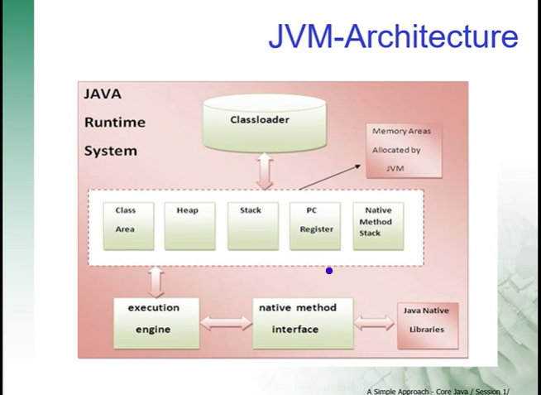

**Classloader:** is a subsystem of JVM that is used to load class files. E.g: java.lang(no need to import, it’s imported by default so that we can use sop, java.util etc

**Heap** store objects

**Stack** stores variables

**Program Counter Register:** It contains the address of the JVM instruction currently being executed.

**Native Method Stack:** used to store other programming language functions. Ex: printf, and can write JavaScript etc..

**Execution Engine:** It contains a virtual processor and interpreter.

Lamda Expressions, Java streams are new features in **Java 8**.

**Installation:**

Go to bin folder of JDK and copy that url.

To where u want to save files, Open cmd prompt from that address bar,

*SET PATH=paste that JDK Bin Path link*

java -version (to get version).

**First Program in Java in Notepad**

Class HelloWorld

{

Public static void main(String[] args)

{

System.out.println(“Hello World”);

}

}

**Save** this file as its class name, i.e: HelloWorld.java

**Compile** as javac HelloWorld.java in cmd prompt (.class will created check with cmd dir)

**Execute/Run** as java HelloWorld ( to get our output)

**Analyzing the program**

/* */ -> Multi line *comments*, // -> single line comment.

*class* declares the definition of class.{ }

The program execution begins from *main()* method.

*public* keyword is an access specifier, controls the visibility and scope of class members.

The *static* keyword allows the main() method to be called, without need to create an instance of the class.

*Args[]* is an array of type String.

The *println()* is method. System is a class of lang package, out is an object.

The *void* keyword tells the compiler that the main() doesn’t return any value when it is executed.

**Program in Notepad Taking Input through Command line Args**

Class CommandLineArg{

Public static void main(String[] args)

{

String name = args[0];

int a = Integer.parseInt(args[1]);

int b = Integer.parseInt(args[2]));

int sum=a+b;

System.out.println(“Hello ” +name);

System.out.println(“Sum : “+sum);

}

}

**Save** : CommandLineArg.java

**Compile:** javac CommandLineArg.java

**Execute:** java CommandLineArg Gosling 100 20

**Output:**

Hello Gosling

Sum: 120

**In eclipse**: write same code, Right click and Run as Run Configurations -> select CommandLineDemo, Go to arguments next after main, Give args, in program arguments Gosling 100 20. and Run we get output.

**Visual Development tools**

Includes a source code editor and many more.

Examples: Net beans, Eclipse, VS Code Editor etc.

**Eclipse:**

File -> new -> **Java Project** -> Give Name & deselect module.info -> Java perspective will open.

Right Click on project -> new -> class ->className(HelloWorld) -> Finish

**Super class=java.lang.Object**

**.java files in src and .class files in bin.**

AutoComplete feature: ctrl+space (to get suggestions)

main ctrl+space to get psvm())

sysout or syso +ctrl+space to get sop.

For multi-line comments, /* and press enter and then write comments.

Ctrl+shift+/ to get multiline comments for already written one.

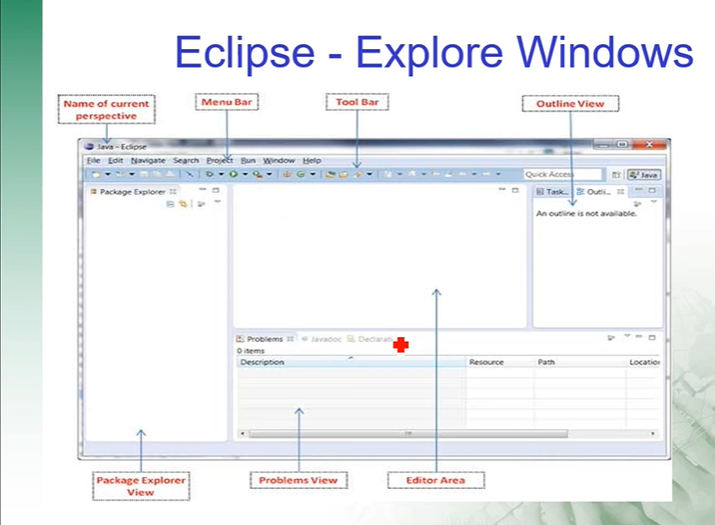

**First Program in Eclipse:**

public class HelloWorld{

public static void main(String[] args){

System.out.println(“Hello World”);

}

}

**save** it. Right click on editor. **Run** as -> Java Application.

We will get **output** in console.

**Java Input – Using Java Scanner**

* Java has plenty of ways of accepting input.
* A java scanner is the fastest, easiest way to get input from user.

**Scanner scan = new Scanner(System.in);**

* It creates a Scanner instance scan to accept input from user
* Import Scanner class - **import java.util.Scanner**
* Once Scanner object is created, use it to store a value to a variable using next() method.

**String name = scan.nextLine(); 🡪 for sentence**

**String name=scan.next(); 🡪for single word**

**int n1=scan.nextInt();**

**Double n1=scan.nextDouble();**

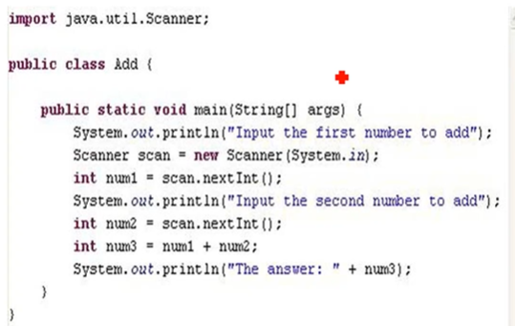

**Types Of Errors in Java:**

* Syntax Errors/compiler Errors

Errors that are detected by compiler are called syntax errors. Syntax errors result from errors in code construction, mistyping a keyword, omitting punctuation etc. Easy to detect these errors because compiler tells u where they are and what caused them.

* Run Time Errors

RTE are errors that cause a program to terminate abnormally. They occur while running if the environment detects an operation that is impossible to carry out. Input mistakes typically cause RTE. (E.g: /0 or entering wrong input etc..)

* Logical Errors

It occurs when a program doesn’t perform the way it was intended to.

**Java Language Fundamentals**

Java Basic Building Blocks:

* **Data Types**: Determine the type of data to be stored in a memory

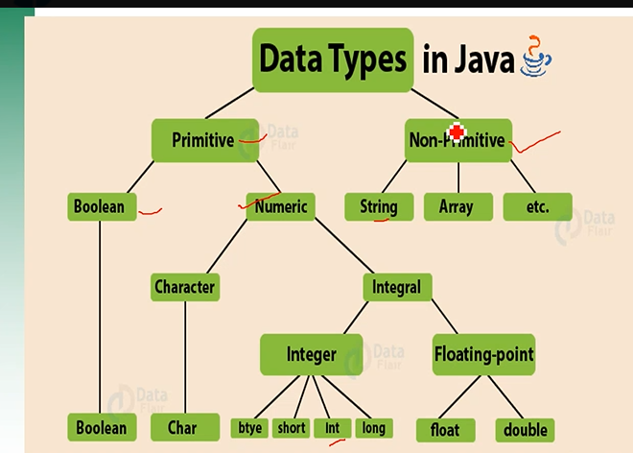

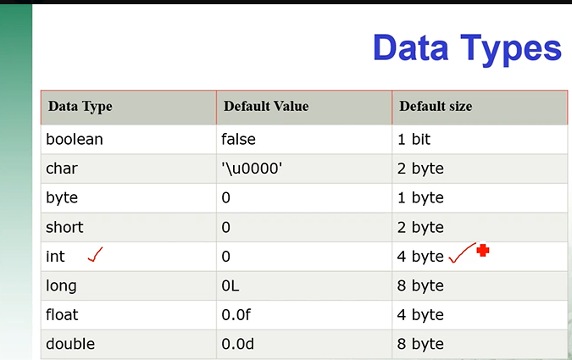

* **Variables**: A variable is named memory location.
* **Local** : A variable declared inside the body of the method is called local variable.
* **Instance:** A variable declared inside the class but outside the body of the method. It is not declared as static. It’s value is instance specific and id not shared among instances.
* **Static:** A static variable is common to all the instances(objects) of class as it is a class level variable. Memory allocation for static variable happens only once, when the class is loaded in the memory.
* **Operators**: Is a symbol that operates on one or more arguments to produce a result.
* **Control Flow statements**: Programs are executed in sequential order. It allows variations in this sequential order.

**Three Components of a variable declaration are**

1. Data type
2. Name
3. Initial value to be assigned(optional).

**Unicode System**

* Unicode is a universal international standard character encoding that is capable of representing most of the written languages.
* Before Unicode, there are many language standards.
  + ASCII(American Standard Code for Information Interchange) for the United States.
  + ISO 8859-1 for European Language
  + KOI-8 for Russian
  + GB18030 and BIIG-5 for Chinese, and so on.

**Problems before Unicode**

* A particular code value corresponds to different letters in the various language standards.
* The encoding for languages with large character sets have variable length.
* Some common characters are encoded as single bytes, other require two or more byte.
* lowest Value \u0000, Highest Value \uFFFF.

**Type Casting**

float c 34.89675f;

int b = (int) c + 10; //convert c to an integer.

**TYPES OF DATA CONVERSION**

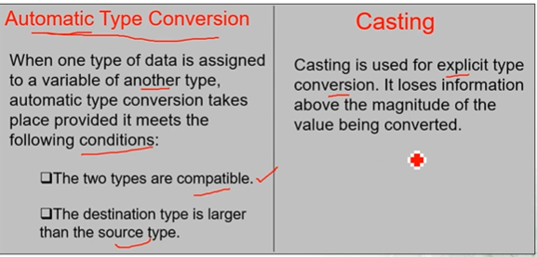

Type Promotion Rules:

* All byte and short values are promoted to int type
* If one operand is long, the whole expression is promoted to long.
* If one operand is float, the whole expression is promoted to float.
* If one operand is double, the whole expression is promoted to double.
* E.g: int+float=float output only.

**Operators:**

Arithmetic Operators for mathematical calculations. +,-,*,% etc.

Relational Operators for testing relation between two operands. The result is Boolean. --, >=, <= etc

Logical Operators work with Boolean operands. &,|,^ etc.

Conditional Operators ?=,=,*=,/=,+=,-=

Assignment Operators =

**Control Flow Statements:**

All application environments provide a decision making process called control flow statements that direct the application execution.

Types of Control Flow Statements:

1. Decision-making/ conditional statements/branching statements

* if-else
* switch-case

It is used as an alternative for if-else-if statement.

Switch(expression){

case 1:

action1 statements;

break;

case 2:

action2 statements;

break;

…………………..

case N:

actionN statements;

break;

default:

default statements;

1. Loops : Used to repeat a block of code. A set of statements executing repeatedly, until a particular condition is true.

* while
* do-while

**int** i=1;

**do** {

System.***out***.println(i);

i++;

}**while**(i<=10);

* for

**Debug is a technique to see how our code actually working line by line. In eclipse, window->perspective -> Open Perspective ->Debug. On Right side we can see extra windows like variables, breakpoints, expressions etc. Keep breakpoint on some line (double click on line ex:14 small circle will appear to manually control our program) Right click and debug as Java application we can see next lines execution by clicking on step over or F6. To come to again java perspective window->perspective->Java**

1. Jump Statements:

* break: to terminate the block
* continue: to skip specific iteration and executes other.

**ARRAY**

Array is a data structure that stores data of same data type in consecutive memory locations.

3 ways to declare an array:

Datatype identifier [];

Datatype identifier []; = new datatype[size];

Datatype identifier []; ={value1, value2…};

**Enhanced For loop:**

It is a read-onl loop, where values cannot be modified.

For(T element:Collection Object/array)

{

Statements(s);

}

**int**[] n1= {1,2,4,1,6,7,-3};

**for**(**int** i:n1) {

System.***out***.print(i+ " ");

}

System.***out***.println();

}

**Object Oriented Concepts{Page: 11-17}**

**Object**: Represents an entity in the real world. Objects are created in the heap.

An Object is a concrete entity that exists and which has a well-defined state and behavior(properties/attributes and methods).

Dog dog1 = new Dog(); //creating object of class example

**Message Passing**: Objects communicate with each other by passing messages.

**Class**: A class defines an entity in terms of common characteristics and actions.

A class is a blueprint for a group of objects that have common properties and behaviour.

Example: Employee(class) 🡪cashier, manager, salesman etc are objects.

**Property:** A characteristic possessed by an object or entity when represented in a class is called a property.

**Methods**: (sub-programs) Actual implementation of an operation. An action performed by an object is called method.

Methods allows us to reuse the code without retyping the code. It may/may not return a result.

**Types of methods:**

1. Standard library methods (println(), sqrt(), sort(), toString(), close(), nextInt(), next() etc are methods. But length is a property.)
2. User-defined methods

Modifier returntype methodName(Parameter list)

{

//method body

}

E.g:

public int max(int x, int y){

if(x>y)

return x;

else

return y;

}

int a = max(20,30); //method call

(20,30) are actual parameters or arguments

(x,y) are formal parameters.

Methods calls are implemented through the stack. The returned value from method stored in stack frame.

**Java Naming Conventions:**

* The name must not contain any white spaces.
* Should not start with special characters
* ***Class*** should start with Uppercase letter. It should a noun(like Employee).
* ***Interface*** should start with Uppercase letter. and should be an adjective such as Runnable, Remote, ActionListener.
* ***Method*** should start with lowercase letter. It should be a verb such as main(), println(). If the name contains multiple words, use camelCase. such as actionPerformed().
* ***Variable*** should start with lowercase letter such as id, name. Should not have special characters. If it has multiple words, use camel case. Avoid using one character variable such as x,y,z.
* ***Package*** should start with lowercase letter such as java, lang. If it has multiple words, it should seperated by dots(.) such as java.util, java.lang.
* ***Constant*** should be in uppercase such as RED. If the name contains multiple words, it should be separated by an _ such as MAX_PRIORITY. It may contain digits but not as the first letter. It is declared using *static final int* MIN_AGE=18; static-> age here is a class level variable.

**Java Reserved Words**

* These are keywords, which are reserved functions. We can’t use keywords as an identifier. else it throws an error.

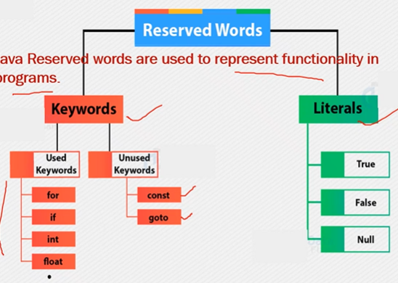

**Encapsulation:**

* Information hiding
* Hiding implementation details of an object from its user.
* Packing things together and presenting them in their new integrated form.
* “*The process of hiding attributes, methods or details of implementation is called encapsulation*”.

**Abstarction:**

* Technique of dealing with the complexity of an object. Focusing only on the essential details and overlooking the non-essential details of an object.
* *“The process of identifying and grouping the attributes and actions related to a particular entity as relevant to the application is Data Abstraction”.*

**this keyword:**

* Used inside any instance method to refer to the current object.
* this.x=x //left side x represents instance variable and right side x represents parameterized variable

**Constructors:**

* Method invoked whenever an instance of a given class is created. Same name as the class and no return type. Java allocates memory for the object, initializes the instance variables and calls the constructor methods.
* Two types of constructors:

1. Parameterized constructors
2. Implicit constructors

**Inheritance**

* Inheritance in Java allows us to carry the features of the parent class to the subclasses.
* It is the mechanism in which derived class acquires the properties of a base class.
* Here base class is super class and derived class is the subclass.
* Code reusability is the main use of inheritance.
* It represents the **IS-A** relationship which is also known as parent-child relationship.
* It allows to create hierarchy of classes.
* Moreover, u can add new methods and fields in current class also.
* Keyword **extends** is used to inherit a class.
* Base class constructor is invoked before the derived class(to invoke base class constructor super keyword is used.

**Types of inheritance in Java:**

1. Single inheritance – the features and methods of the super class are inherited by a single sub class.
2. Multilevel inheritance – the base class inherits the features of the super class, and simultaneously it acts as a super class for another base class.
3. Hierarchical inheritance - the features of one super class are inherited by more than one child class.
4. Multiple Inheritance - one class inherits the properties of multiple classes. we can have one child class and n number of parent class. But java don’t support this, use need to achieve this using interfaces.
5. Hybrid inheritance - combination of any two or more above inheritances. it’s also achieved using interfaces.

**Aggregation in Java**

* If a class have an entity(obj) reference, it is known as aggregation.
* It represents **HAS-A** relationship. E.g. A Car has a engine.
* *Aggregation is an association that represents a part of a whole relationship where a part can exist without a whole.*
* It follows one-way or one-to-one relationship. eg: The dept. can have students but vice versa is not possible.
* Ending one entity won’t affect another, but can be present independently.
* Helps for code-reusability.
* It has a ***weaker*** relationship.

**Composition in Java**

* Composition is a more restricted form of Aggregation.
* It is an association that represents a part of a whole relationship where a part cannot exist without a whole.
* If a whole is deleted then all parts are deleted.
* It has a ***Stronger*** relationship.
* A house has a relation with rooms
* In composition, both entities are dependent on each other, if a house is deleted then all rooms for that house should be deleted.

**Polymorphism**

* It means “Many forms”.
* It is described as “one interface, many implementations”.
* It refers to the ability of an object(or a reference to an object) to take different forms of objects. (E.g: Man takes many roles).
* Types of Polymorphism:
  + - **Static Polymorphism:** A polymorphism that is resolved during compile time is known as static polymorphism. E.g*., Method Overloading.* **🡪** It is a feature that allows a class to have two or more methods to have the same name but with different parameter lists. Argument lists varying in type or number.
    - **Dynamic Polymorphism:** It is a process in which a call to an overridden method is resolved at run time. It is called run time polymorphism. *E.g., Method Overriding* 🡪 It is a feature that allows a subclass or child class to provide a specific implementation of a method that is already provided by one of its super-class or parent classes. E.g., Bowling method(). Subclass and superclass have methods with same name and signature. Overridden method of subclass will be invoked when called by a subclass object. Method in super class will be hidden. super.methodname() is used to call super call version of the method. There must be IS-A relationship (inheritance). Final methods can’t be overridden.

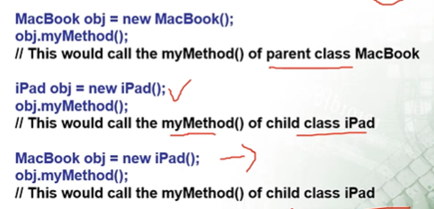

**Binding:** Connecting a method call to the method body is known as Binding.

* Types of Binding:

1. Static binding(also known as Early Binding) 🡪 when type of object is determined at compile time. If there is any private, final or static method in a class there is static binding.

Animal a=new Animal();

a.eat() 🡪 static binding

1. Dynamic Binding(also known as Late Binding) 🡪 when type of object is determined at run time.

Animal a = new Dog(); //called **UpCasting**

a.eat(); 🡪 Dynamic binding

**Reference :** Reference holds the address of an object/ instance.

Student s1 = new Student(); 🡪 s1 is a reference of type Student and points to the object of type Student and will be used to access instance variables and methods.

**Access Specifier:**

Information hiding is one of the most imp features of OOPS.

1. private 🡪 accessible only to members of the class
2. protected 🡪 accessible to members of the class and members of its subclass
3. public 🡪 accessible to members and non-members of the class
4. default 🡪 accessible to members of the class in the same package.

**private -> default -> protected -> public (More hiding to less)**

**Method Modifiers**

1. **static**: is used when a programmer needs to access a class member independent of any object of the class. E.G: main() method is declared static as it can be invoked by JRE without creating an instance of the class. It is mainly used for memory management.
2. can call other static methods.
3. must access static data
4. cannot use super or this keyword.
5. Syntax for invoking a **static method** is : ***Classname.methodname();***
6. we can apply static keyword with variables, methods, blocks and nested classes.
7. **Static Variables/class variables :** It is common to all the instances(or objects) of class because it is a class level variable. We can’t declare static variables in main method. Only a single copy of static variable is created and shared among all the instances of the class. E.g: static String college = “AEC”; //static variable
8. **final:**
9. Variables content can’t be modified. final variables are nothing but constants.
10. methods cannot be overridden by sub class.
11. Reference object should not change.
12. we can’t extend a final class.

**Java Abstraction:**

* It basically deals with hiding implementation details and showing only the functionality to the user.
* There are two ways to achieve abstraction in Java

1. Abstract class (0 to 100%)
2. Interface (100%)
3. **abstract keyword:** abstract is a non-access modifier in java. It is applicable for classes, methods but not variables. Method without any body are abstract methods.

* Certain methods in the super class do not contain any logic and need to be overridden in the subclass. The keyword abstract is used for such methods.
* Syntax : abstract type method_name(parameter_list).
* Any class that contains one or more abstract methods must be declared as abstract.
* abstract class cannot be instantiated, constructors and static methods can’t be abstract.
* An abstract class can have object references that can point to a subclass object. (upcasting)
* Abstract class can have abstract or non-abstract methods. It can have final methods, constructors and static methods also.

1. **interface:** interface in java is a blueprint of a class. It can have only public members. can contain constant variables which are public, static and final by default.

* can extend another interface using extends keyword. cannot contains instances of itself.
* Java interface also represents the IS-A relationship.
* It can be instantiated like abstract class.
* Since Java 8, we can have default and static methods in an interface. Since Java9, we can have private methods in an interface.
* It is used to achieve abstraction, loose coupling. It supports the functionality of multiple inheritance.
* Loose Coupling means reducing dependencies of a class that use different class directly. Tight Coupling means classes and objects are dependent on one another.
* Interface is a collection of abstract methods.
* A class describes the attributes and behaviours of an object, An interface contains behaviors that a class implements.

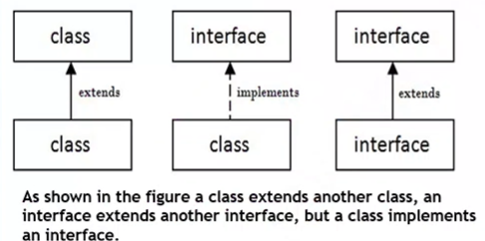

Abstract classes can have abstract or non-abstract methods.

Interface must have only abstract methods by default.

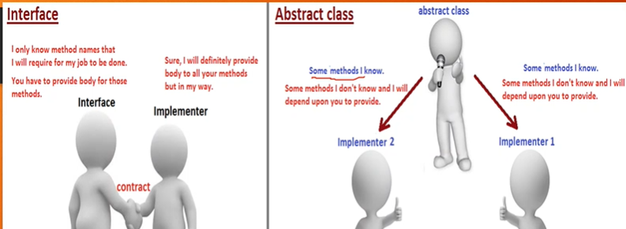

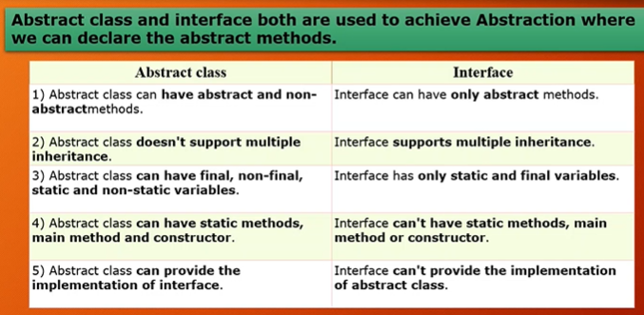

**Universal Super Class – Object class**

* It is because every class u create in java automatically inherits the object class.
* The object class is the parent class of all the classes in java by default.
* The definition of object class in java.lang.package.
* hashcode(), toString(), getClass(), equals(), finalize() are the methods in this class which you can override in your class.
* equals() method is used to check if two objects are equal or not.
* Object obj = getObject().
* equals methods checking for content/values in the objects. == operators for reference comparison(address comparison)

**Exception**

* Exception is an abnormal condition/event that disrupts the normal flow of the program. It is an object which is thrown at runtime.
* Exception occurs for many reasons, some of them are – invalid user input, device failure, loss of network connection, physical limitations, code errors, opening an unavailable file etc..
* To prevent automatic termination, need to fix error and is called **error handling**.
* try – program statements to be monitored are contained within this.
* catch – exceptions caught and handled in rational manner.
* finally – clean-up codes get executed
* throw – exceptions thrown manually
* throws – specifies exceptions thrown by a method.

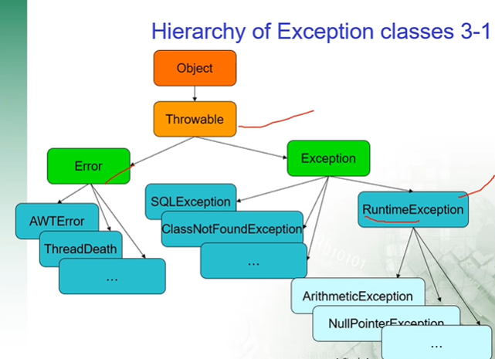

* **Error**s are associated with JRE. These are impossible to recover. **“Unchecked errors**”, occur at run-time. E.g: OutOfMemoryError, VirtualMachineError, AssertionError.
* Exceptions are possible to recover. It can be checked(**Compile time exceptions)** or unchecked(**Run time Exceptions)**, can occur at compile time or run-time.
* Types of Exceptions:

1. Checked Exception(Compile time exceptions): if it occurs, the method must be handle the exception or it must specify the exception using throws keyword. The classes which directly inherit Throwable class except RuntimeException and Error are known as checked Exceptions. Eg: IOException, SQLException etc.
2. Unchecked Exceptions(RuntimeException): Eg: ArithmeticException, NullPointException, ArrayIndexOutOfBoundsException etc.

* **Multiple Catch Blocks:** Single piece of code can generate more than one error. When exception is thrown each catch statement is inspected in order, and the first one whose type matches that of the exception is executed. After one catch statement executes the other are bypassed.
* **Throw** : used to throw an exception explicitly, only object of throwable class or its sub classes can be thrown. Program execution stops on encountering throw statement.

**Throwable class : T**here are two possible ways to get an instance of class Throwable, using a parameter in catch block and next is creating instance with new operator.

* **Throws :** used to handle checked exceptions, we can declare multiple exceptions in one go using throws keyword.

**Java Package :**

* It is a group of similar types of classes, interfaces and sub-packages. It maybe built-in or user-defined. java.lang, awt, javax, swing, net, io, util, sql etc are built-in packages.
* Used to categorize the classes and interfaces so that they can be easily maintained, provides access protection, removes naming collision.
* java.lang 🡪 System.class, String.class

java.util 🡪 ArrayList.class, Map.class etc

* **Syntax:** *package <packagename>;*
* To use in other class import <packagename>.*; or import <packagename>.<classname>;

**String Class:** String is a sequence of characters. In Java , String is immutable objevt which means it can’t be changed once it created. The java.lang.String.class implements Serializable, Comparable, CharSequence interfaces.

**CharSequence interface :** It is used to represent the sequence of characters. String, StringBuffer and String Builder classes implement it. For mutable strings, u can use StringBuffer, StringBuilder.

**Creating a String :**

1. Literal
2. using new keyword

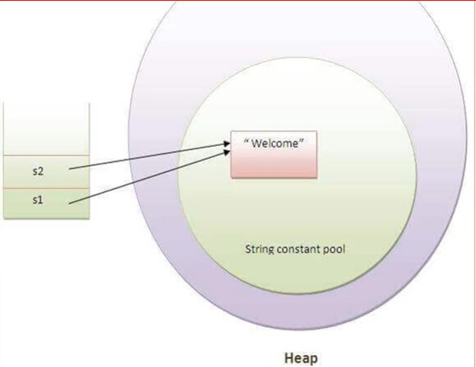**String Literal :** It is created by using double quotes. String s = “Java”;

* Each time u create a string literal, the JVM checks the string constant pool first. If the String already exists in the pool, a reference to the poled instance is created. If the stringdoesn’t exist in the pool a new string instance is created and placed in the pool.

**E.g:** String s1 =”Welcome”

String s2 = “Welcome” //it doesn’t create a new instance

**By new keyword:** String s = new String(“Welcome”); //created two objects and 1 reference variable. JVM will create a new String object in normal(non-pool) heap memory, and the literal “Welcome” will be placed in the String constant pool. The variable s will refer to the object in a heap(non-pool) memory.

String()

String(String value)

String(char [] value)

String(byte [] value)

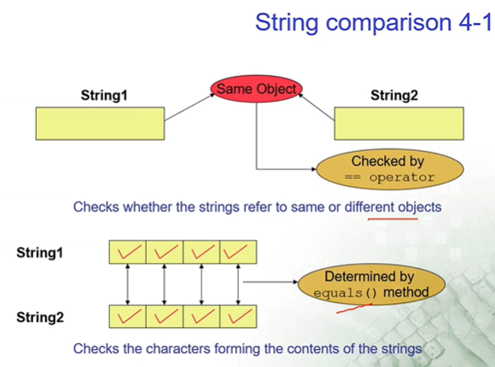

**StringBuffer class :** It represents a string that can be modified. Strings that use concatenation operator(+) create a string object automatically. public StringBuffer() 🡪 reserves room for 16 chars.

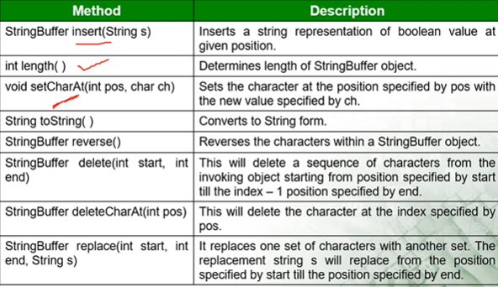

**StringBuilder** : It is not synchronized(not thread safe). Remaining is same as StringBuffer. Where you have only a *single thread* accessing your object then use StringBuilder.

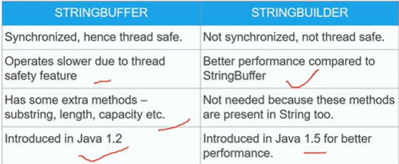

**Wrapper Classes**: A wrapper class is a class whose object wraps or contains a primitive data types.

* They convert primitive datatypes into objects (boxing). Objects are need if we want to modify the arguments passed into a method.
* java.util.package handles only objects and hence wrapper classes used in this case also.
* Wrapper class objects allows null values while primitive data types doesn’t allow them.

int n1 = 5;

Integer n2 = new Integer(n1); //Integer – wrapper classes

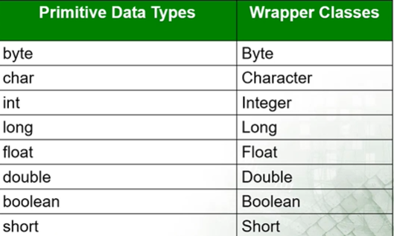

**JAVA Collections**

**Generics :**  It is term that denotes a set of language features related to the definition and use of generic types and methods. Now, Generics force the Java Programmer to store a specific type of objects. It provides type safety.

A class that is defined with a parameter for a type is called a generic class or a parameterized class.

*Advantages:* Type Safety: we can hold only a single type of objects in generics. Type Casting also not required. It is checked at compile time so problem will not occur at runtime.

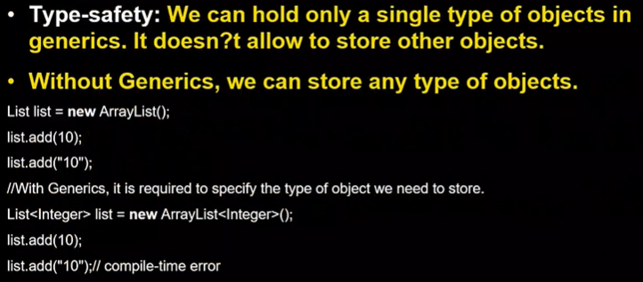

*Types:*  1. Generic Type class, 2. Generic Interface, 3. Generic Method, 4. Generic Constructor

Parameterized classes / Generics: The class ArrayList is a parameterized class. It has a parameter Base_Type, that can be replaced by any reference type to obtain a class for ArrayLists with the specified base type.

Syntax : BaseType <Type> obj = new BaseType <Type>();

Naming Convention: By convention, type parameter names are single, uppercase letters. E – Element, K – Key, N – Number, T - Type, V – Value, S,U,V etc. – 2nd,3rd,4th types.

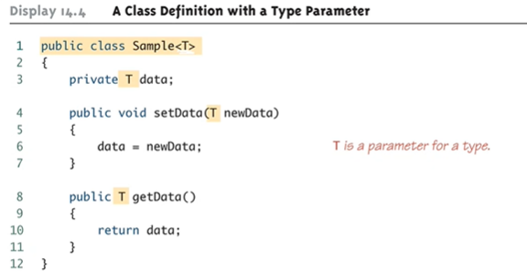

**Collections** are used to store retrieve and manipulate data to transmit data from one method to another. An object of the collection class groups multiple elements into a single unit.

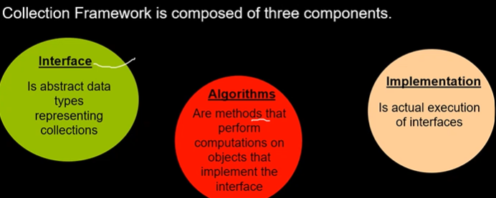

**Collection Classes:** The collection interface(java.util.Collection) and Map interface (java.util.Map) are the main root interfaces of Java collection classes. The ***java.util*** package contains all the classes and interfaces for Collection framework. EXAMPLE for Collections: KiddyBank, School bag, classroom etc.

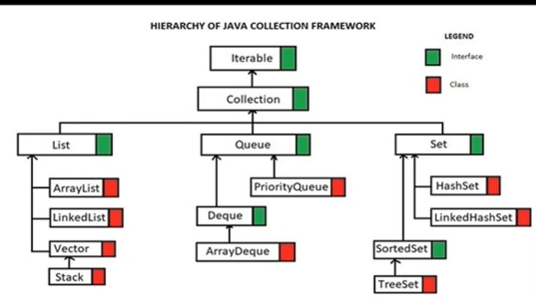

**Methods Of Collection Interface**

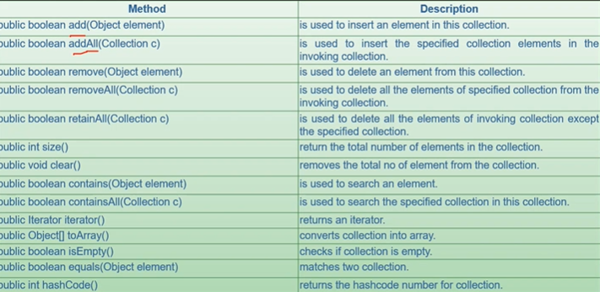

**Iterator interface :** It provides the facility of iterating the elements in forward direction only. It is a Java cursor used to iterate a collection of objects. It is applicable for all collection classes, hence is called Universal Java Cursor. It supports both READ and REMOVE operations.

**Iterator Methods:** 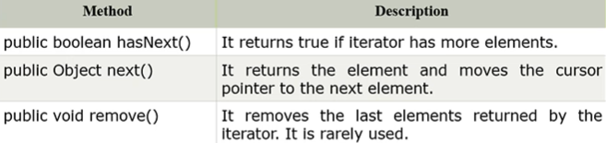

**Collections Class:** It consists of only static methods which are used to operate on objects of type collection.

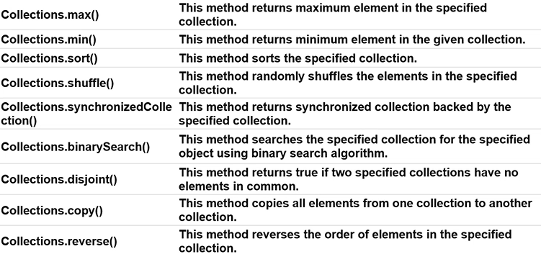

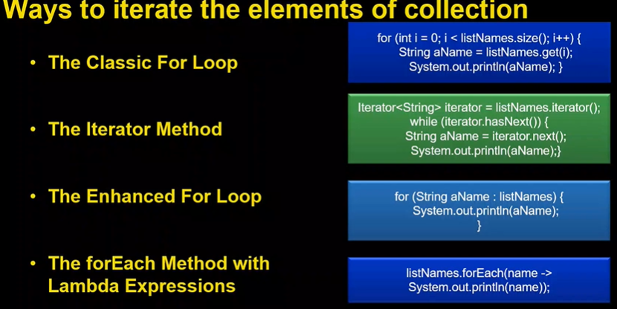

**List interface:**

* It is the child interface of Collection interface. It inhibits a list type data structure in which we can store the ordered collection of objects. It can have duplicate values. It is implemented by the classes ArrayList, LinkedList, Vector, and Stack.
* List <data-type> list1 = new ArrayList();
* List <data-type> list1 = new LinkedList();
* List <data-type> list1 = new Vector();
* List <data-type> list1 = new Stack();

**ArrayList**

* An ArrayList object is a variable length array of object references. It is used to create dynamic arrays.
* Extends AbstractList and implements List interface.
* It gives better performance when accessing and iterating through objects.
* Can contain duplicate elements, maintains insertion order.

**LinkedList**

* LinkedList is a generic class that extends the AbstractSequentialList and implements List, Queue, and Deque interfaces.
* Not very different from ArrayList. But the point of difference is in how the list is maintained at the core.
* Can contain duplicate elements, maintains insertion order.
* It is non-synchronized.
* LinkedList manipulation is fast because no shifting needs to be occurred.
* It can be used as list, stack or queue.
* Like arrays, It is a linear data structure. Unlike arrays, linked list elements are not stored at contiguous location; the elements are linked using pointers.
* Easy for insertion/deletion
* Random access is not allowed, we can’t do binary search with linked list.
* Double linked list helps in forward and backward traversion.

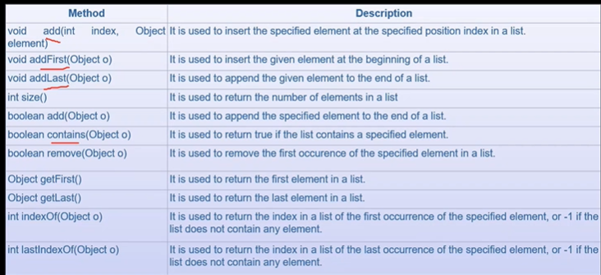

**For searching operations go for ArrayList. For frequent adding and removing go for LinkedList.**

**ListIterator Interface**

* It performs iteration in either direction, modify the list during iteration and obtain the iterators current position in the list.
* It extends Iterator interface.
* It is useful only for list implemented classes.
* Unlike Iterator, it supports all four operations (CRUD – Create, Read, Update, Delete). previous() and next() are there here. hasPrevious() and hasNext() also.

**Set Interface**

* A set is a collection that can’t contain duplicate elements.
* It is an Unordered grouping of elements.
* It has no new methods defined inside set interface, so we have to use Collection interface methods only with Set subclasses.

**HashSet Class (not thread-safe)**

* It is used to create a collection that uses a hash table for storage.
* It inherits the AbstractSet class and implements Set interface, Cloneable, Serializable.
* It is not guaranteed to be inserted in same order in HashSet. Objects are inserted based on their hash code.
* HashSet stores the elements by using a mechanism called *Hashing*.
* we can add null like hset.add(null) -- for String

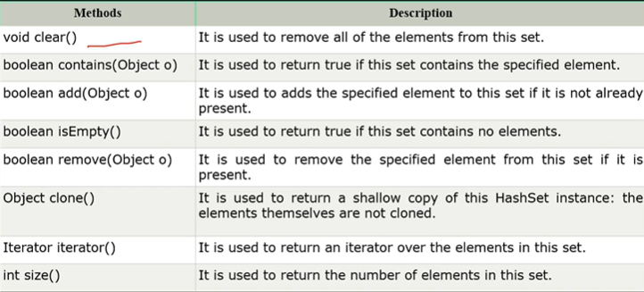

**TreeSet (not thread-safe)**

* It doesn’t allow duplicates
* Unlike HashSet, it doesn’t allow null values.
* It sorts elements in ascending order by default.
* TreeSet<Integer> ts = **new** TreeSet<Integer>(Comparator.*reverseOrder*());
* Use Comparator.reverseOrder() to get output in descending order.
* It implements the SortedSet interface so duplicate values are not allowed.
* Along with HashSet methods, we have first() and last().

**HashSet gives better performance(faster) than TreeSet for the operations like add, remove, contains, size etc.**

**Map**

* java.util.Map interface represents a mapping between a key and a value.
* The map interface is a not a subtype of Collection interface.
* Therefore, It behaves a bit different from the rest of the collection types.
* A map cannot contain duplicate keys and each key can map to atmost one value. (Keys should be unique and values can be duplicated)
* Some implementation allows null key and null value (HashMap, LinkedHashMap) but some do not(TreeMap).
* Maps are perfectly for key-value association mapping such as dictionaries.

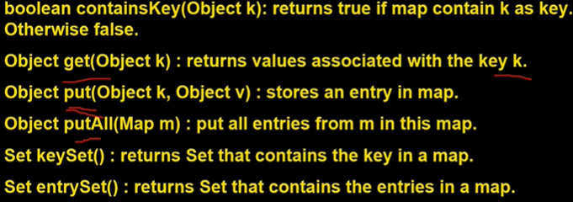

* **Map.Entry Interface:** Entry is the sub interface of Map. So we will be accessed it by Map.Entry name. It provides methods to get key and value. Object getKey() and Object getValue().

**HashMap**

* It contains values based on the key.
* Implements the Map interface and extends AbstractMap class.
* It contains only unique elements.
* It may have one null key and multiple null values.
* It maintains no order.

**HashMap is faster than HashSet because unique key is used to access object.**

**Comparable interface**

* It is used to order the objects of user-defined class. It is used to compare and Sort objects.
* A comparable object is capable of comparing itself with another Object.
* It contains only one method named *compareTo(Object).*
* It provides single sorting sequence only, i.e. u can sort the elements on based on single data member only. It maybe rollno, name or age or anything else.
* Collections class only provides static methods for sorting the elements of a collection if it is of primitive types or String.
* For sorting based on multiple fields use comparator interface. It has one method compare(…)

**Java I/O**

* Java I/O(Input and Output) is used to process the input and produce the output.
* Java uses the concept of a stream to make I/O operation fast.
* The java.io.package contains all the classes required for input and output operations.
* We can perform file handling in Java by Java I/O API.

**Java File Class**

* It is an abstract representation of file and directory path name. It can be either absolute or relative. It has several methods for working with directories and files.

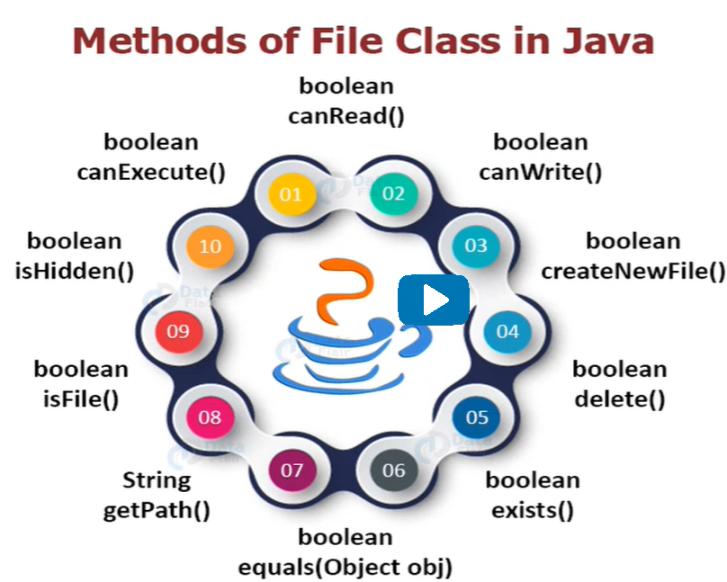

**Stream**

* A stream is a way of sequentially accessing a file. (A stream is a continuous flow of data).
* Java performs I/O through streams.
* A stream is linked to a physical layer by java I/O system to make input and output operation in java.
* It is a channel for sending information in first-in, first-out manner.

**Kinds of streams 🡪** InPutStream(reading data from source),OutPutStream(sending data to destination).

* In java 3 streams are created for us automatically and attached with our console.

1. System.out 🡪Standard output stream
2. System.in 🡪 Standard input stream
3. System.err 🡪 Standard error stream

**Processing Streams**: It operates on the data supplied by another stream.

**Types of Streams:**

1. Byte Stream : for handling i/o of byte(8 bits)/raw data/binary files. Extends InputStream and outputStream. ByteStream should be used only for the most primitive I/O.
2. Character Stream : for handling i/o of characters/Strings/text) A character size is typically 16 bits. uses Unicode and can be internationalized. Extends Reader and Writer classes in java.io package.

* Reader, Writer , InputStream, OutputStream all are abstract classes.

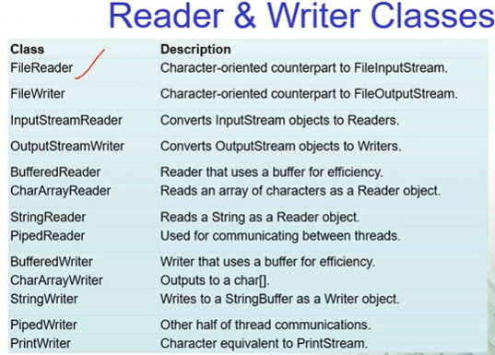

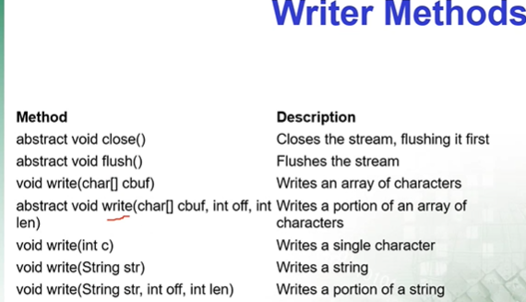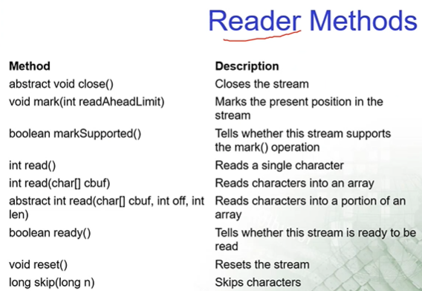

* 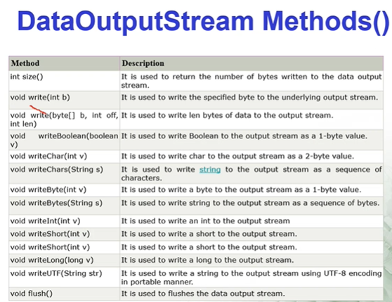To improve the performance while reading and writer, we are using **Buffered** Writer and **Buffered** Reader. A buffer size needs to be specified, if not it takes default value.

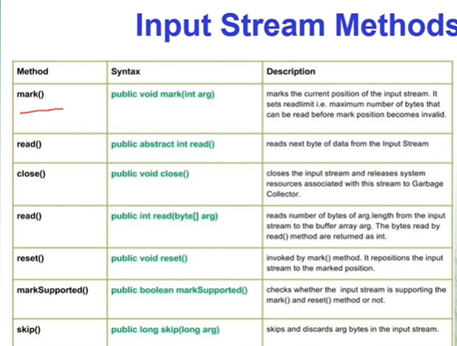

* All methods except mark() and reset() are overridden.
* // writing data using output stream
* // reading data back using input stream

**Object Serialization & De-serialization**

* To read an entire object from or write an entire object to a file, java provides Object Serialization.
* A serialized object is represented as a sequence of bytes that includes data and its type information.
* After a serialized object has been written into a file, it can be read from the file and deserialized to recreate the object in memory

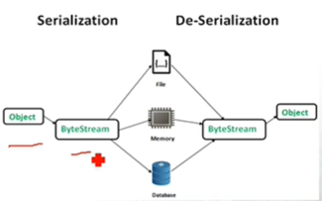

* **Serialization** is a mechanism of converting the state of an object into byte stream helps object to travel across a network.(ObjectOutputStream class has writeObject()). The class must implement java.io.Serializable interface. If a field is not serializable then that will be transient.
* **Deserialization** is a reverse process where the byte stream is used to create the actual java object in memory. (ObjectInputStream has readObject())
* *Node 1 -> Object -> Serialized -> Network -> Deserialized -> Object -> Node 2*
* A **transient variable** is a variable that cannot be serialized. Variables may be marked transient to indicate that they are not part of the persistent state of an object.

**Java 8 Features**

**Intro to Java 8**

* It’s released in early 2014. Most talked about feature was lambda expressions.
* It has many other imp features such as default methods and static methods in interface, stream API and new data/time API, functional interface. Nashron, JavaScript Engine to execute JS code.

**Lambda Expressions**

* It’s just an anonymous function with no name with a list of formal parameters and without being bounded to an identifier. Its helpful in Collections, to iterate, filter & extract data.
* **Syntax:** (parameters) -> expression (or)

(parameters) -> {statements ;} (or)

() -> expression

(Person p1, Person p2) -> p1.getAge().compareTo(p2.getAge());

(Lambda Parameters)(Arrow)(Lambda body)

* It has optional type declaration, optional parenthesis around parameter, optional curly braces, optional return keyword.

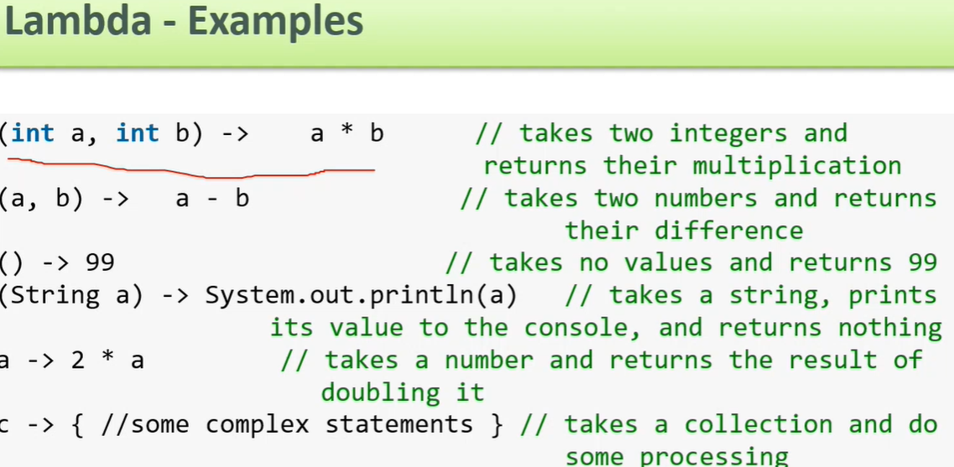

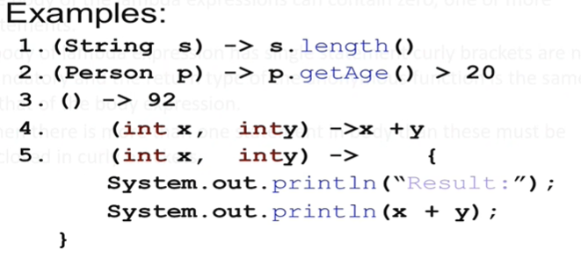

**Functional Interface:** It is an interface with only one abstract method. E.g: a Comprable interface with a single method ‘compareTo’ is used for comparison purpose. A functional interface can be annotated but it’s optional. (FunctionalInterface).

**Method Reference:** In java we can use references to objects either by creating new objects or by using existing objects. List list = new ArrayList();

List list2 = list;

* Method reference is a shortand notation of a lamda expression to call a method.
* If your lamda expression is like this, str->System.out.println(str) then u can replace it with method reference like this, System.out::println
* The :: operator is used in method reference to separate the class or object from the method name. Object ::methodName

**Date & Time API**

* Java 8 introduced a new date-time API under the package java.time.
* Important classes are Local and Zoned.
* LocalDate, LocalTime, LocalDateTime

**Streams API**

* A stream in java can be defined as a sequence of elements from a source that supports aggregate operations on them. The source here refers to a Collection or Arrays who provides data to a stream. (java.util.stream)
* A stream is a conceptually fixed data structure, in which elements are computed on demand.
* Streams doesn’t support indexed access.
* can easily be outputted as arrays or lists. It doesn’t store data, designed for processing data.
* Designed for lambdas.
* Lazy Object creation: objects are created at run time whenever it is required.
* Lazy Class Loading: classes load into memory only when they are first referenced. it reduces memory usage.

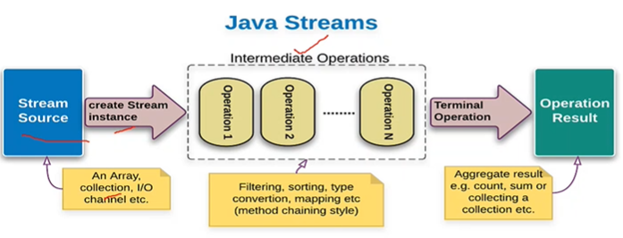

**Stream Methods – Intermediate Operations**

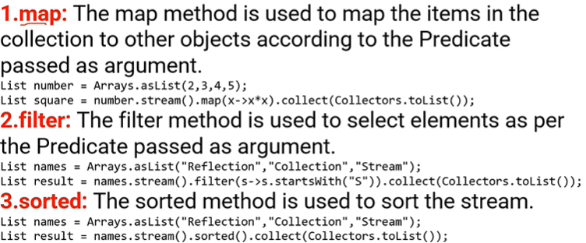

**Stream Methods – Terminal Operations**

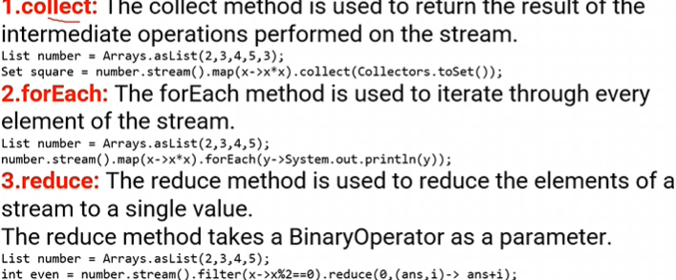

**Junit Framework**

* Junit is a tool for test driven development.
* **Test Driven Development**: It is a software development process which includes test first development. It means that the developer first writes a fully automated test case before writing the production code to fulfill that test and refactoring.

1. Firstly, add a test.
2. Run all the tests and see if any test fails.
3. Update the code to make it pass the new tests.
4. Run the test again and if they fail then refactor again and repeat.

* **Legacy code:** A code without testing is known as legacy code.
* **Test Driven Development Tools:** Junit(unit testing framework), APACHE JMeter(mainly for load/performance testing), Mockito.
* **Software Testing:** Testing is the process of checking an application that it is working as expected. It means for a known input it must give the expected output.
* **Code Under Test:** The code which is tested is typically called code under test.
* **Test Fixture:** A text fixture is a fixed state in code which is tested used as input for a test. (Test precondition).
* **Test suite :** Collection of test cases.
* **Types of testing:** unit testing, Integration testing, System testing, acceptance testing
* **Unit testing:** Test each individual module(class/method) separately.
* A **Unit test** is a piece of code written by a developer that executes a specific functionality in the code to be tested and asserts a certain behavior or state.
* The percentage of code which is tested by unit tests is called **Test Coverage.**
* **Types of Unit Testing:** 1. Manual testing- process of executing a test case without tool any support. 2.Automated Testing-process of executing a test case with a tool support.
* **Selenium** is one of the mostly widely used open-source web UI automation testing suite.
* **Junit** is an open-source unit testing framework for java programmers. It’s only used for unit testing. Junit was written by Erich Gamma and Kent Beck.
* ***Example****:* for the class Calculator, Create a new Junit Test Case->new JUit4 test -> Name: CalculatorTest -> Mark @Before setup() and @After teardown() -> classUnderTest: Browse(Calculator) -> Select the methods for Calculator -> Finish.
* import org.junit.*;import static org.junit.Assert.*;
* Declare your test class in usual way.
* In that declare an instance of the class being tested.

<https://notepad.pw/t5nf4284>

<https://howtodoinjava.com/spring-boot2/testing/rest-controller-unit-test-example/>

<https://www.springboottutorial.com/unit-testing-for-spring-boot-rest-services>

**3 tier Architecture:** Presentation logic(UI technologies), Application logic(spring, meanStack, PHP etc.), database logic(hibernate-JDBC. Mysql, postgresql, mongodB).

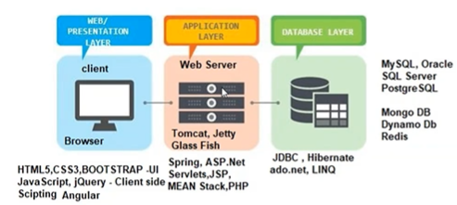

Sleep mode - saving the state of machine.

**Hibernate**

**Hibernate -** Saving the state of an object. It is used to implement database logic. To connect with DB, hibernate is used. Hibernate framework created by Gavin King in 2001.

* Hibernate is a framework in java which comes with an abstraction layer and handles the implementation internally.
* The implementation includes tasks like writing a query for CRUD operations or establishing a connection with the databases etc.
* **Persistence**: Saving the state of an object in DB.
* *“ Hibernate is open-source lightweight and an ORM (object relational mapping) tool .”*
* **ORM** - Java classes mapped with RDBMS tables.

(Java Application -> Object -> ORM -> Database)

* **JDBC** stands for Java database connectivity ad provides a set of java API for accessing the relational databases from java program.
* **ORM** is the solution to handle impedance mismatches - **Inheritance , Identity, Associations, Navigation, Granuality - (**sometimes u have an object model with more classes than the number of corresponding tables in database).
* **Few Other ORM tools -** Castor, TopLink, Hibernate etc..
* **hibernate** takes care of mapping java classes to satabase tables using xml files and without any line of code. Tables will create automatically.
* **HQL** (Hibernate Query Language) is an object-oriented query language, similar to SQL. Instead of operating on tables and columns, HQL works with persistent objects and their properties.

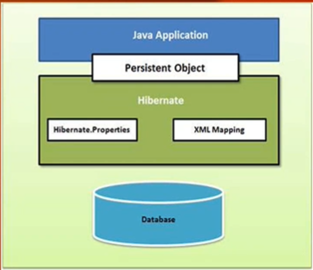

***Database***

Install MariaDB -> Google -> click mariadb Foundation -> Download -> MariaDB server -> MariaDB 10.6.8, windows, x86_64 MSI package ->Download. Remember the password which u have given at the time of installation. ( I have given **root** )

HeidiSQL (similar to mysql) we get in desktop. It is an IDE for working with MariaDB.

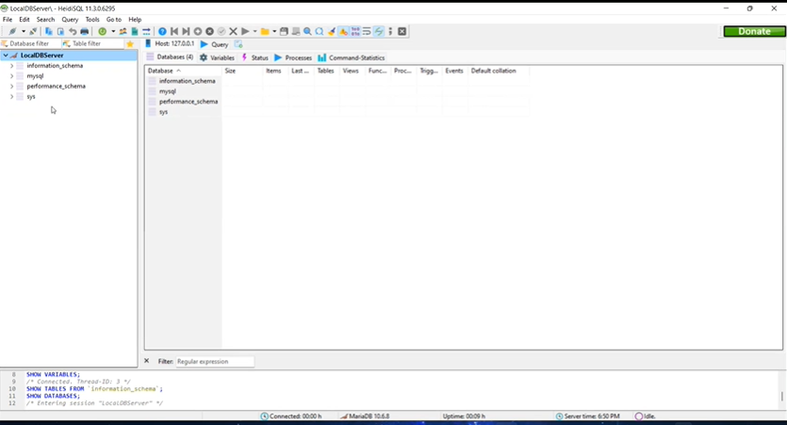

In eclipse -> help ->eclipse marketplace -> Install Hibernate Tools(Helios)3.4.x. ->select all trustors.

**Example Using HeidiSQL**

Click on HeidiSql, sessionManager -> NEW -> right click on unnamed and name it as LocalDB Server. root -> <give password which u have given at the time of installation> click on open.

Click on Query tab then write cmnds like CREATE DATABASE trainee; USE trainee; //then click on run selection. Click on green Button(Refresh) then we get student database left side.

**RDBMS /NoSQL softwares**- Used to store and manage data.

**RDBMS examples**: MySQL, MariaDB, Oracle, SQL server

**NoSQL examples:** MongoDB, DynamoDB, Reddis

Java 🡨🡪Hibernate/JDBC 🡨🡪Database

**MySQL database**: It is set of interrelated tables used to store & manage data.

**Database**: Collection of tables

**Table**: Collection of records.

**Record**: Collection of fields.

**How to create a demo maven Project and work with Hibernate:**

**Using pom.xml**

In eclipse file new-> maven project ->check default only ->catalog:internal select quickstart -> GroupId(org.team): com.wipro.velocity , ArtifactId(Name of the project): hibernate-demo -> finish, we get App.java by default -> run as java app -> we get Hello World output.

In order to work with hibernate from eclipse add jars to our maven created project in pom.xml.

In google type mvnrepository -> search hibernate core -> download hibernate core relocation

click on 5.6.5, select the code under maven and add in pom.xml dependencies.

Another dependency to be add is go to mvnrepo -> serach for mysql -> mysqlconnector -> 8.0.28->copy and add it and update ur maven project. Under maven dependencies folder we can see now all the required dependencies.

1. Click on src/main/java -> new -> other -> hibernate Configuration File ->next -> Database dialect : MySQL 5 , Driver class: com.mysql.cj.jdbc.Driver, connection URL : jdbc:mysql://localhost:3306/training (training db should be already created in HeidiSQL), username:root, password: root(for me) -> Finish.

Open that hibernate.cfg.xml with xml editor and add one new property to automatically create tables.

<property name=*"hibernate.hbm2ddl.auto"*>update</property>

<mapping resource =*"Employee.hbm.xml"*/>

the above resource will be created In step 4.

2. Create a new class - Employee with some properties(Id,fname, lname) then getters and setters under src/main/java.

3.Rename App.java to EmployeeApp.java. Add below lines under main method and imports from hibernate.org.

Configuration cfg = **new** Configuration();

cfg.configure("hibernate.cfg.xml");

SessionFactory sf = cfg.buildSessionFactory();

Session session = sf.openSession(); //Physical connection with database

Transaction t = session.beginTransaction();

Employee e1 = **new** Employee(); //create transient object of Employee

e1.setFirstName("Padma");

e1.setLastName("Uppalapati");

session.save(e1);

t.commit();

System.***out***.println("Data Successfully saved to Database");

session.close();

sf.close();

4.Under src/main/java -> new Hibernate XML mapping file, Add class : Employee -> Finish, code will automatically come here. if u get errors try below one

(or) select -> new -> xml file-> FileName: Employee.hbm.xml -> finish it. and write code manually

<?xml version=*"1.0"* encoding=*"UTF-8"*?>

<!DOCTYPE hibernate-mapping PUBLIC

"-//Hibernate/Hibernate Mapping DTD 3.0//EN"

"http://www.hibernate.sourceforge.net/hibernate-mapping-3.0.dtd">

<hibernate-mapping>

<class name=*"com.wipro.velocity.hibernatedemo.Employee"* table = *"Employee"*>

<id name=*"empId"* type =*"java.lang.Long"*>

<column name=*"EMPID"* />

<generator class = *"identity"* /> <!-- To automatically generates empId-->

</id>

<property name=*"firstName"* type=*"java.lang.String"*>

<column name=*"FIRSTNAME"* />

</property>

<property name=*"lastName"* type=*"java.lang.String"*>

<column name=*"LASTNAME"* />

</property>

</class>

</hibernate-mapping>

5.Execute the EmployeeApp as Java App. we can see that Employee table with data is created under training database automatically with id1. if u change fname and lname then new record will add with next Id.

**Using annotation**

6.Create a Student class, @Entity,@Table,@Id@GeneratedValue all these annotations will be given.

add below line in hibernate.cfg.xml

<mapping class=*"com.wipro.velocity.hibernatedemo.Student"*/>

And also write StudentApp main class similar to EmployeeApp.

**Configuration Object:** It is the first hibernate object u create in any hibernate application. It represents a configuration or properties file required by hibernate. It provides two key components: Database connection( handled through one or more configuration files supported by Hibernate. These files are hibernate.properties and hibernate.cfg.xml.), class Mapping setup. The configuration object creates the connection between Java classes and database tables.

**SessionFactory Object:** Configuration Object is used to create a SessionFactory object. It is a thread safe object and heavy weight object so usually created during start up and kept for later use. U would need one SessionFactory object per database using a separate configuration file.

org.hibernate.boot package for the process of bootstrapping a Hibernate SessionFactory.

**Session Object:** It is used to get a physical connection with a database. persistent objects are saved and received through a session object. these are not thread safe and lightweight and should be created and destroyed them as needed. transient -> persistent -> detached

**Transaction Object:** A transaction represents a unit of work with the database and most of the RDBMS supports transaction functionality. Handled by an underlying transaction manager and transaction(from JDBC or JTA). it is an optional object.

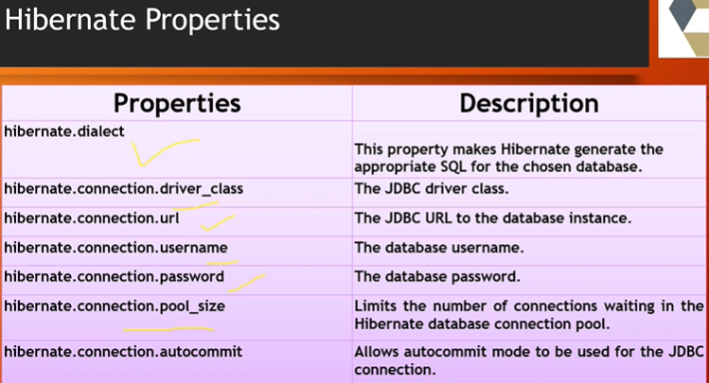

**JPA -** It is a specification of Java which is used to access, manage, and persist data between java object and relational database. Being a specification, JPA doesn’t perform any operation by itself, Thus it requires implementation. So ORM tools like Hibernate, TopLink, and iBatis implements JPS specifications for data persistence.

**Persistent classes:** The java classes whose objects or instances will be stored in database tables are called persistent classes in hibernate.

**Rules of persistent classes:**

* All java classes that will be persisted need a default constructor.
* All classes should contain an ID in order to allow easy identification of your objects.
* All attributes that will be persisted should be declared private and have public getters and setters defined in java bean style.
* These classes should not extend or implement some specialized classes and interfaces.

**Hibernate - Mapping files:** used to instructs hibernate how to map the defined class or classes to the database tables. u should save the mapping document in a file with the format ***<classname>.hbm.xml***

**Annotations :** It is a tag that represents the metadata.

**@GeneratedValue(strategy=GenerationType.IDENTITY)** 🡪 To automatically generate the value 1,2,3

**@Id** -> id refers to the primary key value

**@Entity** -> represents this class is acting as an object

**@Table(name=”some_name”)** -> to give name to table

(same thing is mentioned in simple steps just below this one)

**How to create a maven project for web application using Hibernate**

1.click on new->maven project ->catalog: internal and filter: maven-archetype-webapp->GroupId:com.wipro.velocity, ArtifactId: hibernateweb ->Finish.

But these errors will not effect output.

I’m getting errors in index.jsp. To avoid them add below 2 dependencies in pom.xml.

The superclass Jakarta.servlet.http.Httpservlet not found on build path.

<dependency>

<groupId>javax.servlet</groupId>

<artifactId>javax.servlet-api</artifactId>

<version>3.0.1</version>

<scope>provided</scope>

</dependency>

<dependency>

<groupId>javax.servlet.jsp</groupId>

<artifactId>javax.servlet.jsp-api</artifactId>

<version>2.2.1</version>

<scope>provided</scope>

</dependency>

And also I got error in pom.xml. To avoid that, use below code in <build>. Error is could not initialize class org.pache.maven.plugin.war.util.webappStructureSerializer.

<build>

<plugins>

<plugin>

<groupId>org.apache.maven.plugins</groupId>

<artifactId>maven-war-plugin</artifactId>

<version>3.3.1</version>

</plugin>

</plugins>

<finalName>hibernateweb</finalName>

</build>

Here, we don’t have src/main/java, so click on src main -> new -> java ->finish.

create a new package named com.wipro.velocity under src/main/java.

Go to mvnrepository.com in google, search for hibernatecore relocation and add dependency of version 5.6.5. Also search for Mysql connector 8.0.28 and it.

**Configuring Apache tomcat server in eclipse:**

As it is a webapp, we should have server. So go to tomcat.apache.org and download tomcat version 9. Core->zip download it. Extract all in D:/ But I have diff version 8.5 I’m using that.

Go to eclipse-> window->perspective->java EE -> In servers, It’s showing no servers available. click on it, apache->Tomcat 8.5 browse and select that folder.

If versions is not showing -> Go to help -> install new software ->1st one eclipse releases-> elaborate xml select jst server**,Eclipse java**, eclipse java web/xml**, , eclipse xml editors and tools, eclipse web js next->select on left hibernateweb(project which u need to run) add->finish. Then servers folder will be automatically created. If the add option for hibernate is not coming, then right click on project->properties->facets-> check dynamic web module, java, In runtime->check apache apply and close. Right click on server, add and remove then add it -> finish.

Double click on server, In server location check on use tomcat installation, if that is not enabled, then right click on servers -> properties-> switch location-> apply and close. Then check on use tomcat installation save it. it will work now.

Even it doesn’t work, then delete the server under server below after console and go to window-> preferences-> servers: Run time environments-> select and delete it. close. Then from servers again add it.

If the error is the ports are already in use, then change the port numbers and check by giving that port number in browser.

From the servers we can start and stop the servers. 8080 is the default port of tomcat server. After starting the server, in chrome type htpp://localhost:8080 we can access the tomcat page.

In the index.jsp we have hello world pgm, right click on it, run as -> run on server -> select tomcat under local host,->check always use this server -> next and finish. we get hello world output in browser.

**Same steps in simple way for creating a webapp maven project:**

If any errors still gets, install new version of eclipse eclipse jee-2022-03. Then u get output easily.

**Configuring tomcat server**

1. Open eclipse -> window -> perspective -> java EE.
2. Click on servers tab below -> apache -> version Tomcat 8.5(mine) -> Browse : select that folder tomcat 8.5-> finish.
3. Double click on tomcat 8.5 -> select that use tomcat installation -> save it, if not enabled, Right click on server open properties ->switch location -> apply and close. Now, try to select it.
4. Right click on server tomcat ->Click on add and remove -> add the project u will be running,. If republish is showing just publish it. and start it.
5. We can access the server by giving <http://localhost:8080>.

**Webapp Maven Project**

1. Click on file -> new -> maven project -> catalog: Internal, webapp -> GroupId: com.wipro.velocity, ArtifactId: hibernateweb -> next -> Finish. Errors in pom.xml and index.jsp doesn’t matter.
2. hibernateweb project is created. Go to that expand src, main, select that main create a new folder ‘java’ -> finish.
3. Expand webapp we get index.jsp, click on it Run as -> Run on server. Expand local host select tomcat, check always use the server -> next -> Finish. Restart server and check remember my decision.
4. We get hello world in output.

cont..

1. Under src/main resources create new->hibernate(cfg.xml), Dialect: MYSQL 5, Driver class: com.mysql.cj.jdbc.Driver, url: jdbc:mysql://localhost:3306/training (training is already created folder in HeidiSql. username: root, password: root(I created at the time of sql installation). Add update property in xml file.
2. Create a package named com.wipro.velocity under src/main/java. And create a new class User. (using Annotation configuration).Also change accordingly in index.jsp file. Create register.jsp file as well.
3. Create a new class UserDao under com.wipro.velocity.
4. Start the server, and go to index.jsp Run as ‘Run on Server’. We get the registration form, and the entered details will eb stored in database. Under training folder user100 table will be created and data stored automatically.
5. If u get any error after entering data, go to project -> click on build automatically and in servers clean it :)
6. Another example with Employee - EmployeeTest.jsp, Employee.java, Employee.hbm.xml write one line in hibernate.cfg.xml. To run this open TestEmployee.jsp, and run on server.
7. Another example with Person.java, Candidate.java, Person.hbm.xml, InheritanceMapping.jsp and run it from InheritanceMapping.jsp.
8. Another example with Student.java, StudentClass.java, Student.hbm.xml, Component.jsp, Run component.jsp.

For every example, we should declare in hibernate.cfg.xml.

1. SelectDemo.jsp, Manipulation.jsp is to retrieve the data from tables by using queries.

If u get any error like JSP not run then clean the server, click on build automatically and try it again. If not works, right click on project ->properties ->deployment Assembly -> check whether maven dependencies are there or not. If not add it java build path entries->maven->apply. Also try by cleaning the server and starting again. In jsp files itself we made querying as well.

**SQL -** database query language, *select * from Student* (here Student refers to a table)

**HQL-** Object oriented Query Language, *from Student*(Student refers to a pojo class).

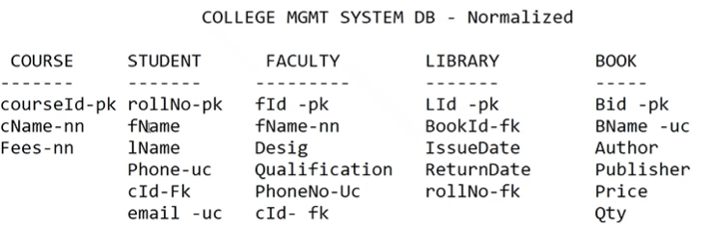

**Hibernate One to One -** No foreign key is created in the primary table. Ex: one employee can have one address and one address belongs to one employee only.

@OneToOne(targetEntity=Address.class,cascade=CascadeType.ALL)

@OneToOne(targetEntity=Employee.class)

Example: In the hibernateweb project - A Customer has a address, a Address is for customer, bidirectional mapping. Add mapping in hibernate.cfg.xml , create OneToOneBidrectional.jsp . Run the jsp file.

** By default if a relation exists between 2 tables, we can’t delete one table as it’s related to another. To avoid this, we are using cascade=CascadeType.ALL. so that we can delete, modify even it ha sthe relation with another table.

**Hibernate One to Many:**

**Example:** In hibernateweb project in JavaWorkspaceVelocity, one Question has many Answers, create OneToMany.jsp. Run this one, after adding few lines in hibernate.cfg.xml. we can use DisplayOneToMany.jsp to display the existing records.

**Spring Framework**

**Problems with Traditional Approach to J2EE**

* J2EE tends to contain excessive amounts of plumbing code like JNDI looku, te/catch to acquire and release JDBC resources etc.
* EJB is overused
* J2EE (servlets, JSP, EJP)applications are hard to unit test

**Spring**

* Spring 1.0 - released in March,2004(by Rod Johnson & Juergen Holler) as J2EE Application Framework.
* Spring is a popular open-source application framework that can make J2EE development easier by enabling a POJO based programming model.
* Consists of - a container, a framework for managing components, and a set of snap-in services for web user interfaces, transactions and persistence.
* Spring is = lightweight, non-intrusive inversion of control(IOC) -(means which provides loose coupling classes -> means where classes are independent of other classes, Dependency Injection is a flavor of IOC), Aspect-oriented, Container, Framework(no dependency on the framework).
* Why Spring? Java beans(pojo class), loosely coupled through interfaces, code is easy to test, can eliminate the need to use a variety of custom properties file formats by handling configuration in a consistent way through out applications and projects.
* Spring can provide an alternative to EJB that’s appropriate for many applications.
* Spring provides a consistent framework for data access, whether using JDBC or an O/R mapping product such as TopLink, Hibernate or a JDO(Java Data Objects) implementation.
* Spring is not a J2EE Application server. But Spring nicely integrates with J2EE Application Server (or any Java Environment)
* Spring provides elegant integration points with: JDO, EJB, RMI, Web Services, JMS, Hibernate.

**Spring Framework**: A lightweight framework that addresses each tier in a web application.

1. **Presentation Layer -** An MVC framework that is most similar to Struts but is more powerful and easy to use. (HTML, Angular..)
2. **Business Layer**: Lightweight IoC container and AOP support(including build in aspects) (our code)
3. **Persistence Layer:** DAO template support for popular ORMs and JDBC.

**Inversion Of Control and Dependency Injection:**

* These are the design patterns that are used to remove dependency from programming code. They make the code easier to test and maintain.

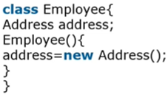

* There is dependency between the Employee and Address (tight coupling). Because in above code we are trying to create an object of another class.
* IOC makes the code loosely coupled. In such case, there is no need to modify the code if our logic is moved to new environment.

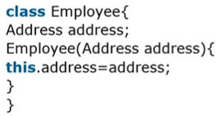

* In Spring, IOC container is responsible to inject the dependency(nothing but object). We provide metadata to the IoC container either by XML file or annotation. Dependency Injection in Spring can be done through constructors/setters/fields.

**Advantages of Spring Framework**

**Predefined Templates** - for JDBC, Hibernate, JPA etc. Don’t need to write the code for exception Handling, creating connection(which we done in hibernate), creating statement, commiting transaction, closing connection etc. We need to write code for executing query only. Thus it save a lot of JDBC code.

**Loose Coupling** - because of dependency injection.

**Easy to Test** - due to dependency injection. EJB or Struts application require server, but spring doesn’t require server.

**LeightWeight** - because of POJO implementation

**Non-invasive** - The spring framework doesn’t force the programmer to inherit any class or implement any interface.

**Fast Development** - due to dependency injection and also as it supports various frameworks

**Powerful Abstraction** - to JavaEE specification such as JMS, JDBC, JPA and JTA.

**Declarative Support** - for caching, validation, transactions and formatting.

**We have Business Logic like Servlet why go for Spring?**

In servlet, we have servlet objects for each functionality of applications. If we develop Gmail using servlet, then we need to have - LoginServlet object, ComposeMailServlet object, LogoutServlet object, and more. Finally, we need to manage and configure each servlet object of Gmail in web.xml.

But Spring has one servlet object for all Number of functionalities.

**Architecture of Spring**: well organized consisting of seven modules.

1. **Spring AOP**
2. **Spring ORM** - related to database access, provides integration for ORM Api’s including Hibernate.
3. **Spring Web** - part of spring web application development stack, which includes Spring MVC.
4. **Spring DAO (**Data Access Object) - primarily for standardizing the dataaccess work using the technologies like JDBC, Hibernate or JDO.
5. **Spring Context** - Package builds on the beans package to add support for message sources, observer design, ability for application objects to obtain resources using a consistent API.
6. **Spring Web MVC** - provide Model View Controller implementations for web applications
7. **Spring Core** - provides Dependency Features, and BeanFactory.

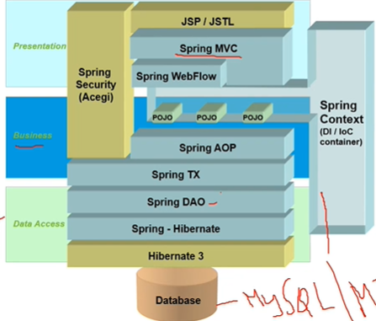

**MVC (Model-view-controller)** is a industry standard web development framework.

**Model** corresponds to all the data related logic that user works with. **View** component is used for all the UI logic of the application. **Controller** acts as an interface between Model and View components. It is used to handle all interactions and input. It processes all the business logic and incoming requests.

**Spring – mvc framework:**

* It provides Model-View-Controller(MVC) architecture used to develop flexible and loosely coupled web applications.
* A model consists of POJO. View is responsible for generating the model data – Html output. Controller contains business logic.

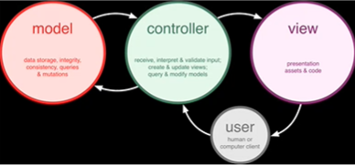

**MVC in Spring:**

* A single **Front Controller** servlet that dispatches to individual controllers. In Spring web MVC, the dispatcher servlet(in web.xml) works as the front controller. It is responsible to manage the flow of the spring MVC application. Request routing is completely controlled by the Front controller.

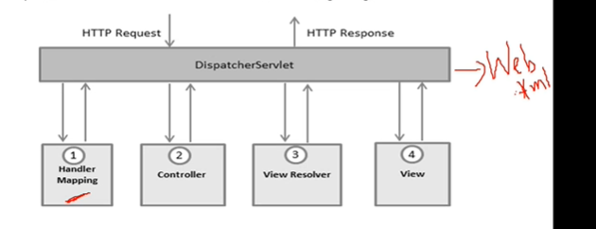

**DispatcherServlet -** Spring’s Front Controller implementation

**Controller** - For handling request, Encapsulates navigation logic

**View** - Responsible for rendering logic

**ViewResolver -** Used to map logical view names to actual view implementations.

**HandlerMapping -** Strategy interface used by DispatcherServlet. Used for mapping incoming request to individual controllers.

**The Deployment Descripter: web.xml** : It describes the classes, resources and configuration of the application and how the web server uses them to serve web requests. web.xml file resides in <web-app> folder under WEB-INF directory.

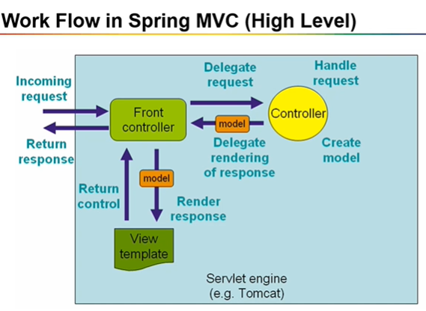

**Creating Web Application in Spring**

In eclipse -> File -> new -> Maven Project -> catalog: Internal, webapp -> GroupId: com.wipro.velocity, ArtifactId: springweb-mvc, Package: com.wipro.velocity -> finish.

1. As src/main/java is not created, create java folder under src/main. Create a package named com.wipro.velocity under src/main/java. Under this package, create 2 packages - com.wipro.model and com.wipro.controller. Under WEB-INF, create a folder named views.
2. Go to mvn repository.com in google, Open Spring context, v-5.3.18 copy and add in pom.xml before junit. Also Spring web MVC with v-5.3.18 add in pom.xml. Both version should match to avoid any error. Also add dependencies for JSTL and servlet-api v-2.5. - these 2 is for creating views (views similar to jsp files).
3. Go to servers rightclick on it, click on add/remove add springweb-mvc. Publish and start the server. Right click on index.jsp Run on server. Then we get output Hello World. We got errors in pom.xml that is nothing to do with output. But if u don’t want error add the plugin mentioned above for hibernate-web.
4. I have added other things in index.jsp, then whatever the href is there, create that method in controller package, with the content name create a jsp file under views folder. change web.xml file, there we mentioned another xml file in param-value, copy that name, Under web-inf, right click create Spring bean configuration file and paste that name here select beans, context, mvc, in below window select latest ones for all, . check entire project springweb-mvc. Run from index.jsp. IF u need any css and images create under resources folder. That resources folder is under webapp, if not copy and paste it. Images download paste and copy under images folder.
5. One example with Employee is done. in registerEmployee.jsp, the path represents the variables in pojo classes. Spring mvc forms are data driven. Run from index.jsp. Expression Language look like this.

<h2>${message}</h2> -> Expression Language look like this.

**Spring Boot** - Zero Effort Spring

* Provides faster and widely accessible ‘getting-started’ experience. Provides a range of non-functional features. Doesn’t generate code. Also, XML configuration is not required.

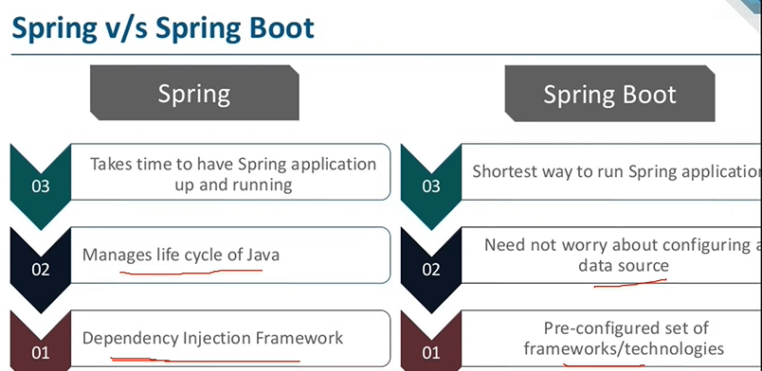

* Spring Boot is a Spring module which provides RAD(Rapid Application Development) feature to Spring framework.
* Spring Boot comes with inbuild server, no external Tomcat or Glass-fish etc, so no need to deploy War files.
* The main disadvantage is, it will be little tough to migrate existing spring enterprise applications to Spring Boot.
* **Spring Boot = Spring Framework + Embedded HTTP servers - XML<bean> configuration or @Configuration**

**Opinionated Approach** : To create Spring Boot Applications, The spring (pivotal team) provides three approaches: Spring Maven Project, Using Spring Boot CLI Tool, Using Spring STS IDE/Eclipse, Using Spring Initializer Website at <http://start.spring.io/>

**Spring Boot Jpa** : It is a java specification for managing relational data in java applications. It allows us to access and persist data between java object/class and relational database. It is a Open-Source API. It is also known as ORM(tool).

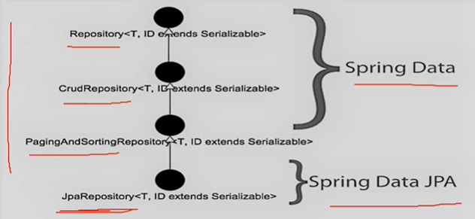

**@Autowired:** To instantiate Our Repository that has extended CrudRepository we can use dependency injection. We ijnject an instance via private field @Autowired annotation. At run time, spring data JPA will generate a proxy instance of Repository and inject it to the instance of Service class. and instance of tService class is injected to controller class

**Custom Repository Methods:** We can start our query methods with find..By, read..By,query..By,count..By,and get..By. Before By we can add expression such as Distinct. After By we need to add property names of our entity. To get data on basis of one or more property we can concatenate property names using And and Or while creating method names. If u want to write query, use @Query to write query.

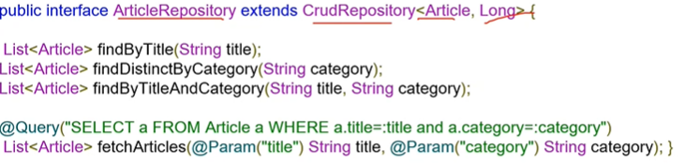

**Creating First Spring Boot Project** -> Install Spring 4 from marketplace

Window->perspective->spring.

Then File->new->Spring Starter Project. Name: springboot-helloworld, Use default location, Type: Maven, Packaging: Jar, version:17, Lang:Java, Group,package: com.wipro.velocity. Description: Demo Hello World Project for Spring Boot. Next-> Select dependencies -> Spring Boot Version:2.7.0, Select Spring web. Next -> finish. Open SpringBootDashboard. After completing ur project, Expand Local from boot dashboard, Right click on ur project name, click on (Re)start. From window->brower->Internal Web Browser from show view / From chrome -> http://localhost:8080/ -> we get Output. Under src/main create a folder webapp. Under that create folder WEB-INF. Create view folder under that. Under src/main/resources, create css and js folders.

**Static Content:** In a spring boot web application, static files like HTML, CSS, JS and Image files in following locations.

**resources/static -** contains static resources such as CSS, JS and images

**resources/templates -** contains server-side templates

**resources/application.properties-** very imp file used to configure your application. to define server’s default port, server’s context path, database URLs etc.

**@SpringBootApplication** - Specifies the starting point of spring boot application. it used to configure Front controller(DispatcherServlet) and Base Package. It includes @Configuration - it flags class as a source of bean definitions, @ComponentScan - searches for beans and components

The main() method uses Spring Boot’s SpringApplication.run() method to launch the application.

**@EnableAutoConfiguration** - inspects the application context and class path.

**@RestController** - it simply adds @ResponseBody to all request mapping methods of a controller class. @GetMapping is a specialized RequestMapping. It specifies that HTTP GET requests to “/hello” are mapped to the sayHello() method.

**Spring Boot Project using DB(HeidiSQL) :**

New Spring Starter Project, Name**: springboot-inventory**, Maven Project, Jar, 17. Group, Package: com.wipro.velocity. Description: project on inventory management system. Next -> select dependencies: Spring web, spring data JPA, MySQL Driver, Spring Boot Dev Tools. Next ->

**Devtools** -> bcoz of this, we don’t need to update our project every time to save the changes.

Improve the development time while working with the Spring Boot application. Spring Boot DevTools pick up the changes and restart the application.

Open Heidi sql, In application.properties we give 3306 port, check in sql, give password(mine is root), connect. CREATE DATABASE myinventory, Run it

(If any error in opening HiediSQl or SQL exception, Open program files -> mariadb, search for my.init -> my -> open in notepad -> after first line copy this line skip-grant-tables -> save and close. Then from search bar -> services ->mariadb -> restart ->close. )

**JpaRepository:** This interface has save(),findAll(),findById(),deleteById(),count()etc.. inbuilt methods of jpa repository for various database operation.This interface will be implemented by class automatically.

**MongoDb** -> install from <http://mongodb.com/try/download/community> , right down side click on Download. Complete -> next -> Finish. Then MongoDBCompass will be opened. Click on connect. If u get connRefuse error. Go to services from search bar. And start mongodb there. Then In mongodbcompass click on connect. it will work. We can create databases there.

Database Name: ims, collection Name: inventory

**Postman :** In <http://postman.com/downloads> Download it from Windows 64 bit. Create free Postman account. click on I know how to use Postman -> start. Clcik on +

**Spring Boot Project with DB(MongoDB - Nosql**):

Eclipse -> File -> New -> Spring Starter Project -> name:springboot-mongodb, Maven 17, Jar, Java, Group, Package: com.wipro.velocity, Des: Spring Boot and MongoDB Demo -> dependencies: Spring Boot DevTools, Spring Data MongoDB, Spring Web -> next -> finish.

In pojo classes we are using @Document(collection=”**”), In MongoDb collection is like a table, data as collection.

**@RestController**: RestController is used for making restful web services with the help of the @RestController annotation.

This annotation is used at the class level and allows the class to handle the requests made by the client.

RestController allows to handle all REST APIs such as GET, POST, Delete, PUT requests.

Rest Controller manages Rest data(representational state transfer) in JSON format(key-value pair).

Open MongoDb compass -> Connect -> Create Database -> Database Name: BookStore (which is mentioned in application.properties) , Collection Name: Book -> Create Database.

Instead of views, we are using postman here. **Postman** is a Rest client. To save it, Click on new -> request -> give some related name and create one collection to store all requests and then make required requests. So Open postman and give requests. For post -> body -> raw -> JSON

{

    "id":101,

    "bookName":"Python Fundamentals",

    "authorName":"Tony Stark"

}

The data will be out in form of JSON format.

**Web Services:** It is an appropriate medium to propagate communication between the client and server applications on www. Advantages of Web Services: Exposing business functionality on the network, Interoperability amongst applications, reduction in cost of communication. (Eg: We can withdraw money from SBI atm using ICICI atm card.) For example: Flipkart provides a webservice that provides prices for products sold via flipkart.com.

**Types of web services:**

SOAP web services: Simple Object Access Protocol is a standard protocol specification for message exchange based on XML. It has 2 components: Client and Service provider.

RESTful Web services: Representational State Transfer is a stateless client-server architecture in which web services are viewed as resources and can be identified by their URLs. It has 2 components: Rest server and Rest client. (Here Request a resource using URI(Uniform Resource Identifier -> eg: http://localhost:8089/api) and Response in XML JSON Format) Message exchange is based on XML/JSON.

Service Producer -> Spring Boot

Service Consumer -> Postman (or) JSP (or) Angular …

Important HTTP Requests: POST -> To add new resource, PUT -> To update existing resource, GET -> To retrieve the resource, DELETE-> used to delete the resource.

HTTP Status codes: 404 -> resource not found, 200 -> success, 201 -> created, 401 -> unauthorized, 500 -> server error.

**Creating a Spring Starter Project using Spring Boot rest, Maven project, Mongodb database, Frontend using Angular**

Open Eclipse -> Spring Starter Project -> Name: **inventory-rest**, Maven Project 17 Jar Java, Group, Package: com.wipro.velocity -> Select Spring Boot Devtools, Lombok, Spring Data Mongodb, Spring web -> Finish. Add configurations in application.properties.

Open MongoDb Compass -> create Database -> Database Name: MyInventory(which we given in app.properties), Collection Name: Test. Just we need to create database. Collections will be automatically created.

For the Frontend, Create one Folder named Angular and open Cmd Prompt from that. type cmd- *ng new ims-rest-controller*. add Angular routing: *y* . Then it will install all necessary packages. Go to that folder, *cd ims-rest-controller* and then *ng serve*. Then goto browser,type <http://localhost:4200/>. Then we should get some default page.

Open VS code, From file -> Open Folder(Angular folder in which ims-rest-controller is created). Expand that folder, src -> app. First change app.component.html. While writing and saving, we can see respective changes in browser.

Change src->index.html file. Change title thenWhatever the classes we are adding for body and app-root, those are the bootstrap classes. and Above body 2 js links also adding. (completed)

Open src->app->app.component.ts, change title.

Open src -> app -> app.component.css and add everything. (completed)

To add any images, go under assets and create a new folder named images, download the images from browser and paste under images.

Open src->app->app.component.html and create navigation bar, align title and add footer as well. Under navigation, add different operation tabs later First writing only for Products List. Without operation we can see in browser by removing that ngIf part.

Open cmd prompt and stop server by ctrl+C. Create new component by typing *ng generate component product-list*, (or) ng g c <component_name>, *ng g c home*. Again start the server, *ng serve*.

Open src->app->app-routing.module.ts and import ProductList Component and Home component.we will get auto-completion feature. And specify the paths for these components in Routes.

Open src->app->app.component.html Add <router-outlet> line. and check in browser by clicking the tabs.

Open cmd prompt, ctrl+c, to stop the server, *ng g service product*(to connect with spring boot restAPI)*, ng g class product*(to define Product class properties). again start the server by *ng serve.*

Open src->app->product.ts, add properties of Product class and initialize them to default.

Open src -> app -> app.module.ts, import HttpClientModule, add that inside imports list also. This is for importing HttpClient in service files.

Open src -> app -> product.service.ts, import HttpClient. Then import Observable. Then give baseUrl, in constructor create instance of HttpClient. Write methods after constructor. Use backquote(` just above tab button)

Open src-> app -> product-list -> product-list.component.ts, import Observable, Router, created productService, Product class. Create list of products, and initialize(creating instance) ProductService in constructor.Then write reloadData() method, and call in init.

Open -> src -> app -> product-list -> product-list.component.html -> add the code. comment 27 to 34 lines.

In eclipse, Open ProductController, then give @CrossOrigin line for interaction between client and server. And the same line in DealerController also. Then start the server.

In browser, the productlist should be displayed now after clicking productlist.

In product.service.ts -> we are using Spring Boot Product service and that is using in product-list.component.ts, form is creating in product-list.component.html.

Stop the server from cmd prompt. *ng g c product-details, ng g c create-product, ng g c update-product*

import them in app-routing.module.ts and give routes.

Do for product_list, product_details,

create_product(using template driven form in html), if u want to use forms, we need to import FormsModule and give in importsin app.module.ts.

Then do for dealer. *ng g class dealer*(dealer.ts and dealer.spec.ts will be created)*, ng g service authentication*(authentication.service.ts, authentication.service.spec.ts will be created)*, ng g component register-dealer, ng g c login, ng g c logout.*

Open dealer.ts and declare all properties. Write required methods in authentication.service.ts, write nav items in app.component.html, import components and give routes in app-routing.module.ts. Then write register-dealer.component.ts and register-dealer.component.html files. Then do for login & Logout component.

In cmd prompt, type ng g c dealers-list. start the server again. Write the method in authentication.service.ts. Then write ts and html files in dealer-list. add Dealers Info in app.component.html. Import dealers-list component in app-routing.module.ts.

{{title}} -> String interpolation

routing -> navigating from one component to another

HttpClient -> used to connect with the service class, connect angular to rest controller.

ProductService -> httpClient ---> RestController -> MongoRepository -> MongodB. Here first 2 from angular side, and other 3 from springBoot side.

Angular offers ActivatedRoute interface class, it carries the information about a route linked to a component loaded into the Angular app template. An ActivatedRoute contains the router state tree within the angular app’s memory.

Observable -> like an interface to handle the Rest data

As a publisher, you create an Observable instance that defines a subscriber function. This is the function that is executed when a consumer calls the subscribe() method. The subscriber function defines how to obtain or generate values or messages to be published.

Snapshot is used to get the Route Parameters

Two types of available forms in angular are: template-driven and reactive forms.

ngModel is for data binding.

**Microservices:**

**Monolithic Architecture**

In layman terms, you can say that it is like a big container where in all the software components of an application are assembled together and tightly packaged.

**Challenges:**

Agility 🡪 even if a small component in an application has to be changed, the entire application needs to be repackaged and assembled together.

Scalability

Fault Tolerance ->even if one component slows, entire application slows down.

Inflexible, Unreliable, Unscalable, Blocks Continuous Development, Slow development, Not fit for complex applications

**Microservices**

It is an architectural style that structures an application as a collection of small autonomous services, modelled around a business domain. Each service is self-contained and implements a single business capability.

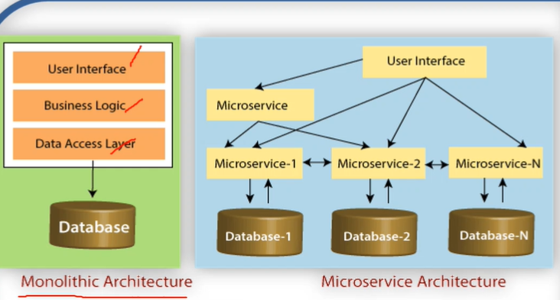

Microservices are small services that work together. The microservice architectural style is an approach to develop a single application as a suite of small services. Microservices are an architecture paradigm wherein a monolithic application is decomposed into small tiny micro applications which are packaged and deployed independently.

As an example, we created separate microservices in microservice-workspace, Spring starter project -> eureka-server -> dependencies(Eureka-client). Create Another spring starter project -> account-microservice -> dependencies(Spring web, Eureka discovery client), Another spring-starter project -> user-microservice -> dependencies(Eureka Discovery Client and Spring Web).

**SWAGGER**

* Swagger is rest API documentation tool.
* For the projects, add 2 dependencies after dev-tools in pom.xml file.

<dependency>

<groupId>io.springfox</groupId>

<artifactId>springfox-swagger2</artifactId>

<version>2.6.1</version>

</dependency>

<dependency>

<groupId>io.springfox</groupId>

<artifactId>springfox-swagger-ui</artifactId>

<version>2.6.1</version>

</dependency>

* Add below line in application.properties

spring.mvc.pathmatch.matching-strategy=ant-path-matcher

* Create a package …..config and class Swagger2Config.
* give @Configuration and @EnableSwagger2 annotations for that class.
* To access it, use url ex: <http://localhost:port/path/swagger-ui.html>
* http://localhost:9095/ims/swagger-ui.html

@Configuration

@EnableSwagger2

**public** **class** Swagger2Config {

@Bean

**public** Docket api() {

**return** **new** Docket(DocumentationType.***SWAGGER_2***);}}

**GIT(Global Information Tracker)** 🡪Central repo github.com

Create repository from github.com

Click on copy button on https link

Go to required folder and open cmd,

**For the first time,**

git config --global user.name “padma”

git config --global user.email [padmauppalapati360@gmail.com](mailto:padmauppalapati360@gmail.com) (mail must be git mail)

cont..

git init

git add .

git status (On branch master by default)

git commit -m “first commit 1.0”

git remote add origin <paste the copied link>

git push -u origin master (u stands for upstream)

**Version Control:** It is the management of changes to documents, computer programs, large websites, and other collections of information. These changes are usually termed as “versions”. git is a version control system. Github is a Central repository.

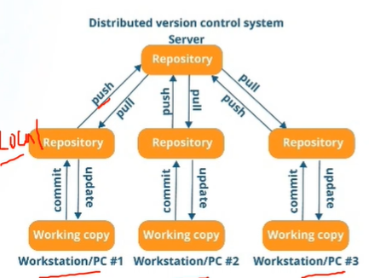

**Why VCS**?

collaboration, storing versions, backup, helps for easy analyzation

**Features of Git:**

* Distributed
* Compatible
* Supports non-linear development of software
* Branching
* Lightweight
* Speed
* Open-source
* Reliable
* Secure

**Repository:** A directory or storage space where ur projects can live. There are two types: Central(github) and Local(our system).

**Generation of token in GitHub**

Go to github.com, settings -> developer settings -> personal access tokens -> generate new token -> new personal access token -> Note: My Token(any name), Expiration: No Expiration, Select Scope: tick repo -> generate token -> copy the token

save this in notepad in desktop in file named githubToken(example).

**Pushing HTML codes to github**

Create a repository named HTML5, open cmd at that folder in local repo

git init (used to create a local repository .git).

git add . (. refers to your root)

git status

git commit -m “Html version 1.0”

git remote add origin <paste the url of created remote repo>

git push -u origin master

**Pulling codes from github**

Goto any drive where u want to get all those files.

git clone <Copy the link of required code link from github>

**Pushing eclipse projects to github:**

Create new repository named oopsdemo1, copy the url of it.

Goto eclipse workspace, where oopsdemo1 project is created(no need of same name)

right click on required project in project explorer -> team -> share project -> deselect the use or create……… -> click on create -> click on finish ->finish.

window -> open perspective -> git

go to git staging

in lhs we get that repository, click on that, In git staging click on add all ++

In commit message, give oopsdemo version 1.0, author and mail automatically come, if we configure username and mail.

commit and push

right click on src, team, commit

push branch master,

Remote name : origin

give https

Host github.com -> give login id name (github username) give user and password(github token)(In desktop)🡨For me. store in secure store -> preview -> push

After done, right click on folder->team->disconnect

**Creating New Branch**

First go to required folder location and open cmd,

git status //on branch master

git branch //master

git pull //upto date

git checkout -b <branchname> //git checkout -b wiprodemo1 --creating copy of master branch

git branch -a //active branches and master also displayed.

ng generate class candidate //creating new class like making changes. --we can add any new features.

we are changing just new copy wiprodemo1, but not to the master copy.

git add . //to add changes to local repo

git commit -m “added candidate class”

git push origin wiprodemo1

Go to github.com, we can see 2 branches. (we have 2 copies of our project master and wiprodemo1)

But the changes creating new class candidate available only in wiprodemo1.

Generally, if the new changes working fine, then those can merge into master branch later.

In cmd, git branch //to see in which branch we are now in

git checkout master // to move to branch master—then active branch will be master now

git merge wiprodemo1 // to merge wiprodemo1 with master hoping new changes are good.(in practical)

git push -f origin master

u can check now in github, new changes occur in master also

**Usage of Lombok**

Download Lombok jar. <https://projectlombok.org/download>

<https://www.geeksforgeeks.org/introduction-to-project-lombok-in-java-and-how-to-get-started/>

Open any project in Spring-Boot.

Go to model package

Put comment after attribute/variable declaration i.e., from setters/getters to constructors.

With the help of Lombok we can reduce these lines.

Double click on Lombok jar file, and install by specifying the .exe eclipse files and all. click on install.

Go to eclipse -> help -> About eclipse-> check if Lombok is installed or not.

In the pojo class, after @Document annotation line, use

@NoArgsConstructor

@AllArgsConstructor

@Data //used for setters and getters.

From **Eclipse MarketPlace** -> Install below ones

*Eclemma* -> for **code coverage**, Then Right click on your project -> Coverage as 🡪Junit to get report.

*Hibernate Tools (Helios)* -> to use Hibernate If u get errors then install Hibernate Tools(Indigo)

java ee: *Eclipse JST server adapters*-> incase u don’t find apache tomcat server under servers while webapp maven project creation.

*jboss tools:* not to get any errors in hibernate web maven projects.

*Spring Tools 4 (aka Spring Tool Suite 4)* - select last 1 feature and 1st 2 required features -> used to work with Spring Boot Projects.

*Spring Tools 3 Add-on for Spring Tools* (select IDE maven support, Spring data support, Spring IDE Core ) -> to work with spring.

**To edit font size:** window->preferences->font->expand basic->text font->edit

**Default ports**

3306 ->mysql

8080 -> tomcat server

27017 -> MongoDB

8761 -> Eureka-server

Bean - pojo class

dependency - object

Date format : yyyy:mm:dd

@SpringBootApplication - to configure Front controller(DispatcherServlet) and Base Package. It enables auto-configuration and component scan, basic error controller.

**SQL -** database query language, *select * from Student* (here Student refers to a table)

**HQL-** Object oriented Query Language, *from Student*(Student refers to a pojo class).

**Rest Controller** manages Rest data(representational state transfer) in JSON - Java Script Object Notation format(key-value pair).

**ResponseEntity** represents the whole HTTP response: status code, headers, and body. As a result,we can use it to fully configure the HTTP response.

**@PathVariable** is used to extract the value from URI.

**@RequestBody** annotation automatically deserializes the JSON into a Java type . It maps body of web request to the method parameter.

**Cross-origin(origins = “**[**http://localhost:4200/**](http://localhost:4200/)**”)** resource sharing (CORS) is a standard protocol that defines the interaction between a browser and a server for safely handling cross-origin HTTP requests. Simply put, a cross-origin HTTP request is a request to a specific resource,which is located at a different origin, namely a domain, protocol and port, than the one of the client performing the request.

@Document -Maps Entity class objects to JSON formatted Documents

To view the errors of angular/html/js code, after running our application in browser, right click on tab and click on inspect -> console.

**Postman** is a Rest(data) API testing tool.

@PathVariable is used to extract the value from the URI.

To get Boot Dashboard, click on Boot Dashboard green symbol in option shown above in eclipse.

To consume rest/micorservices Services, we have HttpClient component in Angular and RestTemplate method in backend.

@ in java is a annotation(meta data), @ in angular is decorator.

**Frontend**

Internet: Connecting a computer to any other computer anywhere in the world via dedicated routers and servers.

WWW(World Wide Web): It is a combination of all resources and users on the internet that are using the Hypertext Transfer Protocol(HTTP).

**Web Protocols**: A protocol is simply a standard for enabling the connection, Communication, and data transfer between two places on a network. - HTTP, HTTPS, FTP, SMTP.

HTTP(Hypertext Transfer Protocol) for transferring web pages across the internet, url maybe preceded by http://, if u don’t specify, browser will default to HTTP.

HTTPS(Hypertext Transfer Protocol over Secure Socket Layer), it is primarily used on web pages that ask you to provide personal or sensitive info such as password, or credit card details.

FTP(File Transfer Protocol) used to transfer files across the internet.

SMTP(Simple Mail Transfer Protocol), it is a application layer protocol, The client who wants to send the mail opens a TCP connection to the SMTP server and then the mail across the connection. The SMTP server is always on listening mode.

Web Standards: it’s simply the guideline for the mark-up language which determines how a web page displays in a visitor’s browser window. It promotes the use of CSS(Cascading Style Sheets) or design code which is attached to the web page rather than embedded in the page.

Common Web Standards:

Markup Languages: HTML, XHTML, SVG

Stylesheets: CSS

ECMAScript: Java Script

WebSite and Webpage: The first page which opens in a website is the HOME page. There is no restriction w.r.t the site size. One website can span over more than one server also.

**WWW**: It is an integrated collection of web servers across the world.

**Web Server:** It is a collection of websites which are hosted. Eg: Google Server, MS server etc..

**Websites:** It is a collection of Web Pages.

**Web Pages:** It is a collection of Hyper Text, Hyper Links & Images..

**HTML (Hyper Text Markup Language):** It is the static language for specifying the static content of web pages. It is for describing web pages. A markup language is a set of markup tags, which describe document content. Html documents contain HTML tags and plain text. HTML documents are also called as web pages.

* **HTML Tags:** Html tags are keywords (tag names) surrounded by angle brackets like <html>. These are normally come in pairs like <p> and </p>, The first tag is start tag/opening tag and second tag is end tag/closing tag.  *<tagname>content</tagname>*
* Web browsers uses the tags to determine how the content of the HTML page is to be presented/displayed to the user, it doesn’t display HTML tags.
* HTML5 is latest standard for HTML. The need of external plugins are reduced here. Error handling becomes easier. Previous versions started came in 1999. It is also Cross-platform. It is designed to work whether you are using a PC, or a Tablet, a Smartphone, or a Smart TV.
* **<!DOCTYPE html>** for html5 declaration helps the browser to display a web page correctly.

Create a folder HTML5 under training folder. Open VS Code Editor, File->open folder ->select HTML5 folder. Then click on file -> new text file -> click on select a language: type html. To get head and body, type html:5 and click enter. In that file if u type h1/p.., then the open and close tags will get automatically. After writing the file, go to the location of that file in our pc, open that file, it will show in browser, the text will appear as per tags.

Instead of opening that file from location to see output, we can run it from vs code. First go to extensions -> Install ‘Live Server’. Now right click on our file, click on open with live server,same process for stop, then browser will come with output. (or) We can also install ‘open in browser’ from extensions, to see output in vs code itself.(or*) just right click on code click on show preview.*

Tags

Every html file has <head></head> -> where meta and title will be there, and <body></body> rest will be here.

<title></title> -> to give title in title bar.

<h1></h1> -> header 1, similarly we have h2,h3…heading size/importance varies as number increases.

<ul></ul> -> unordered list(.). <ol></ol> -> ordered list(1) <li></li> -> list

<hr> -> horizontal line

<br> -> break

<p></p> -> paragraph

<img> -> for giving images

<a href=” ”> </a> -> anchor tag.

<!--comment-->

<table></table> for table, <tr></tr>:table row, <th></th>:table header. <td><.td>:table data

<canvas> element for 2D drawing

<video> and <audio> element for media playback.

<iframe> </iframe> for youtube video

<article>,<footer>,<header>,<nav>,<section>

Html elements can be grouped together with <div> and <span>.

HTML Blocks: It normally start and end with a new line while displaying in browser. Ex: <h1>, <p>, <ul>, <table>

<div> used as a container for grouping other html elements. (uses: to define layout of a page or to create multiple columns, to set style to group of html elements

<span> used as a container for text. (uses: to set style attributes to parts of text,

Inline Elements: normally displayed without starting a new line. EX: <b>,<tb>,<a>,<img>, <span>

properties/attributes

properties/attributes of body -> bgcolor (<body bgcolor=”aqua”>)

properties of h1,p -> align (<h1 align=”center”>), font tag in which color and face can be given. <h1> <font color=”blue” face=”Arial”> Text </font> </h1>

properties of hr -> color, width, size (<hr color=”red” width=”75%” size=”5”>)

properties of p -> style(<p style="background-color:aqua; font-family: monospace; font-size: large; color: brown">)

properties of ul -> type=”circle/square”

properties of ol -> type=”I/A/a/i” to get alphabets and roman numbers

properties of img -> src, height, width. (<img src="hummus.jpg" width="50%" height="50%" alt="hummus image">)

attributes of table -> border(border=”1”) to increase thickness of border, cellpadding=”10” (space between content and border), cellspacing=”10”(space b/w each cell).

attributes of tr -> bgcolor

attributes of td or th -> align, colspan(to merge 2 columns), rowspan( to merge 2 rows)

For particular words we can give <b>text</b>, <i>text</i> for bold, italic. similar to strong and em tags in HTML5. SUB and SUP tags for subscript and superscript a particular text. like 1<SUP>st</SUP> to get 1st. u tag for underline. small defines smaller text, ins defines inserted text, mark defines marked/highlighted text.

hyperlinks used to link one resource/page to another.

External Hyperlinks: if u link out to another website. Here u just need to give the direct link or the html file name u created in the anchor tag inside href.

Internal Hyperlinks: To link within the same page. To use this, assign id attribute to needed section of your page and use #<idName> that will automatically scroll to refer section by clicking on that hyperlink.

**HTML Styles - CSS(Cascading Style Sheets):** It is used to style HTML elements.

Stylesheet is a collection of formatting styles. Style rules consists of Selector and Declaration.

Syntax: Selector{Declaration}, Ex: H1{Color:Blue} -> Propery:Value = Declaration.

**css can be added to HTML in following ways:**

1. Inline - using style attribute in HTML elements. (to apply to one single occurrence)

<h1 style="text-align: center; color: blue; background-color: deepskyblue; font-family: fantasy;">

1. Internal - using the <style> element in the <head> section. (if one single document has a unique style. defined in <head> section using <style>tag.

<style> body{background-color: greenyellow;} h2{color: crimson;font-family: fantasy; letter-spacing: 10px;} p{color: mediumvioletred;} </style>

Types of selector: Simple selector, HTML selector, Class Selector, ID selector.

use # for id, . for class

in body:

<h1 class="raj">Mozilla is Cool</h1>

in head:

<style> .raj{text-align:center; background-color: darkkhaki; color: cyan;font-family: Georgia;} </style>

1. External - using an external CSS file.

To link to extrernal Stylesheet use this line in body, <link rel="stylesheet" href="NameofFile.css">

(or) @Import url(NameofFile.css); -> to import style sheet called cascading.

HTML Blocks: Html elements can be grouped together with <div> and <span>

Entity: &nbsp -> means non breaking space, we can give for paragraphs.

&lt and &gt means less than and greater than symbols.

&copy -> for copyright symbol

**Forms:** It is a collection of fields on a page. It has Form Header, Input Fields, Action Buttons

tabindex helps to move to next textbox while pressing tab.

We have diff ***input types*** like text, password, checkbox, radio, color, date, datetime-local, email, url, tel, submit, reset.

**Semantic Elements:** Elements with meaning, <form>, <table>, <img>…

**Non-semantic Elements:** <div>, <span> tells nothing about the content.

**CSS3 Transforms:** With this transform, we can move, scale, spin and stretch elements. (using 2d and 3d transforms).

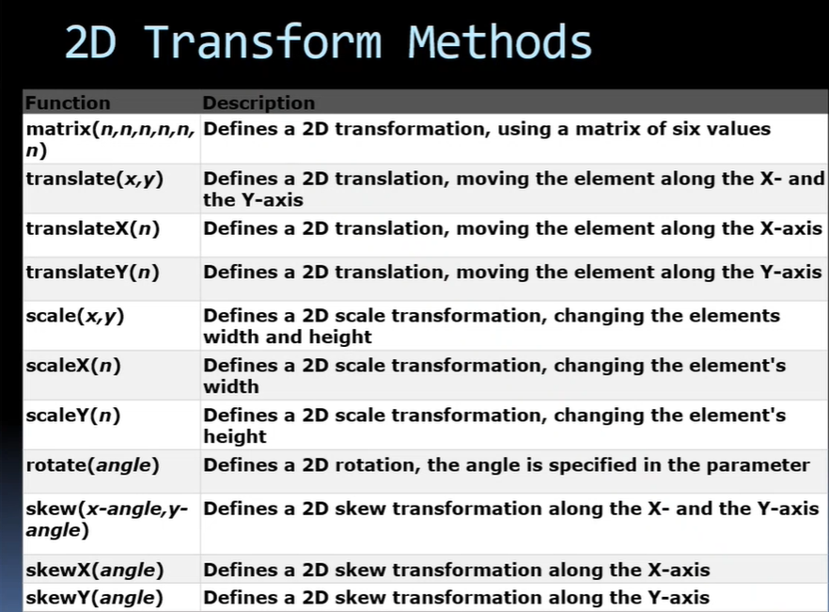

**JavaScript:** It is interpreted, object-based scripting language developed by Sun Microsystems and Netscape. It makes easier to create interactive web pages. JS made the entire work easier by validating the form at the client side. (html+java=js)

**Advantages of JS**: less server interaction, immediate feedback to the visitors, increased interactivity, richer interfaces.

**Applications of JS:** client-side validation, dynamic drop-down menus, displaying date and time, displaying pop-up windows and dialog boxes, displaying clocks etc.

In the html files itself, by using script tag we can write js. <script lang="javascript">*Content*</script>

After running the file, we can see the code by just right clicking on the browser-> view page source. (for all websites😊)

Anonymous Function:JS allows us to define a function without name that is Anonymous function. It must be assigned to a variable.

var x = function(a, b) {return a* b);

var z = x(4,3);

DOM (Document Object Model):The w3c dom is a platform and language-neutral interface that allows programs and scripts to dynamically access and update the content, structure and style of a document.

BOM(Browser Object Model): it allows js to “talk to” browser. Bom objects like js window, js screen, js timing, js navigator, js cookies….

**BootStrap**: It used to make responsive websites. It uses HTML+JS+CSS. BootStrap is a powerful frontend framework that helps to create websites and apps faster and easier. Sites build with BootStrap target mobile devices and scale for large screens depending on screen size. BootStrap package includes scaffolding(grid system, link styles, basic structure), CSS, Components(navigation, alerts, popovers etc..).

Grid system used create different layouts. BS grid system allows upto 12 columns across the page as the device or viewport size increases. total column count 12 (col-md-3,col-md-9 i.e., 9+3=12)

Containers are the most basic layout element in bootstrap and are requires when using grid system. it is basically used to wrap content with some padding. In BS, .container, .container-fluid are pre-defined only. In HTML, . means class selector these are user defined.

Go to website getbootstrap.com from browser, Click on get started, copy code under css and Bundle then open vs code editor bootstrap folder - Create new html file and paste them under title in head and under body.

*BootStrap CSS -*

<link href=<https://cdn.jsdelivr.net/npm/bootstrap@5.1.3/dist/css/bootstrap.min.css> rel="stylesheet"integrity="sha3841BmE4kWBq78iYhFldvKuhfTAU6auU8tT94WrHftjDbrCEXSU1oBoqyl2QvZ6jIW3" crossorigin="anonymous">

*BootStrap JS: (not necessary If we don’t use java script in code)*

<script src=<https://cdn.jsdelivr.net/npm/bootstrap@5.1.3/dist/js/bootstrap.bundle.min.js> integrity="sha384ka7Sk0Gln4gmtz2MlQnikT1wXgYsOg+OMhuP+IlRH9sENBO0LRn5q+8nbTov4+1p" crossorigin="anonymous"></script>

Using BS, **Carousel** will be very easy. i.e., slideshow for cycling through a series of content.

**Angular**

**Installation:**

1. Install Visual Studio Code
2. Install node.js -- <https://node.js.org/en/>
3. open cmd prompt -- d:\training\angular

verify node.js installation in cmd prompt

d:\training\angular\> *node -v*

1. Verify Node package Manager Version> *npm -v* (NPM - Node Package Manager)
2. Install Angular CLI --Command Line Interface for Angular

--Use npm to install Angular CLI

> *npm install -g @angular/cli* (-g: globally, @angular/cli:package name)

-- chk angular version

> *ng --version* (or) ng version

6. Install Git : <https://git-scm.com/downloads> . Select download for windows, Standalone installer - 64 bit git for windows Setup. *> git --version*

For first time using Angular/git:

*> git config --global user.name “padma”*

*> git config --global user.email padmauppalapati360@gmail.com*

**Angular** is Java Script framework developed by Google that allows you to create modern Single Page Application(Instead of serving a brand-new page to visitors, SPA swaps out the old content for new(json) in case of any user interaction.

Properties of Angular: Cross-platform, speed and performance, productivity

**Node.js** is an open-source, cross platform JavaScript run-time environment for executing JavaScript code server-side.

Angular code is written in TypeScript language. Type Script is compiled into Javascript. JS is used in HTMP pages.

**TypeScript:** It is a superset of JavaScript.

Angular provides data binding(Comm. of data between presentation logic and business logic) and dependency injection(injecting dependencies at run time)(loosely coupled) that reduces line of code.

**Angular Application:**

* An application is a module.
* Module contains Components.
* Component uses Services.
* Services contain data and reusable business methods.
* Basic building block of Angular is Component.
* It is said that Angular follows Component/Service architecture. Internally it follows MVC Architecture.

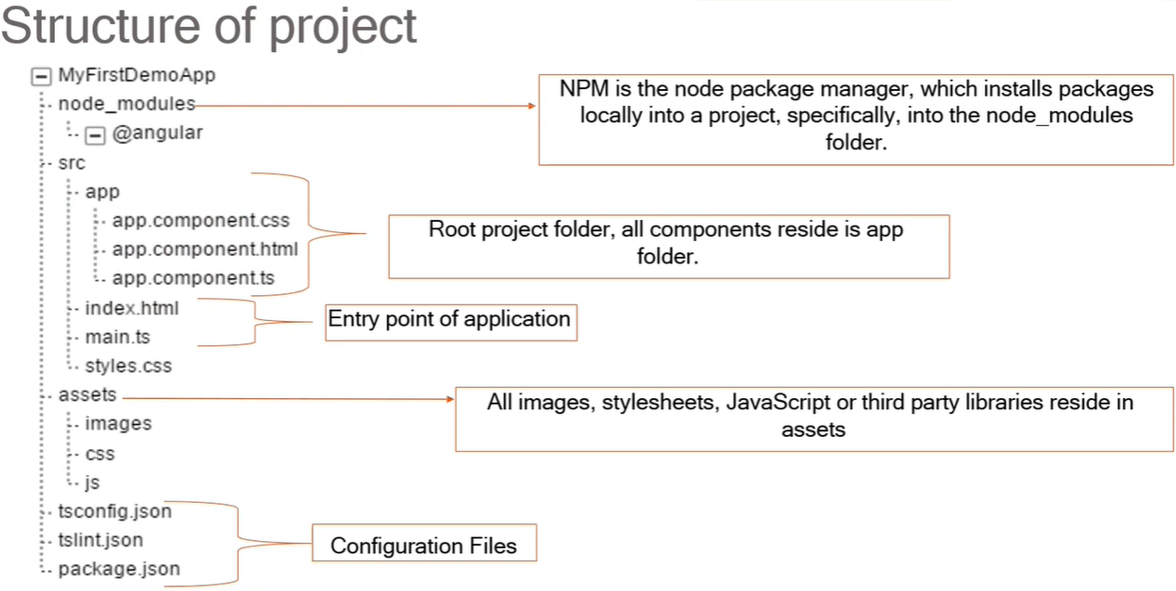

**How App start**

main.ts file is entry point of our application. Main.ts file bootstrap app.module.ts file. This app.module.file bootstrap our first component i.e., app.component.ts. This app.component.ts file render app.component.html file. The app.component.html is final HTML template.

**Component**s are a logical piece of code for Angular application. It is the main building block. The component contains the data & user interaction logic that defines how the view looks and behaves. The view in angular refers to a template.

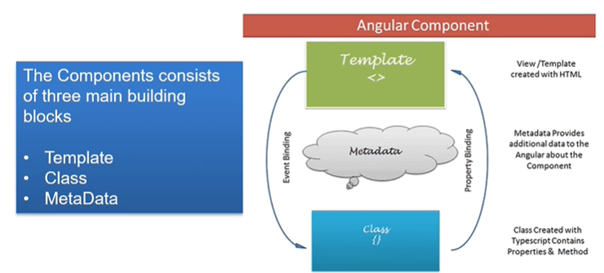

**Data binding:** comm. between presentational/view and business logic.

Dom means html file.

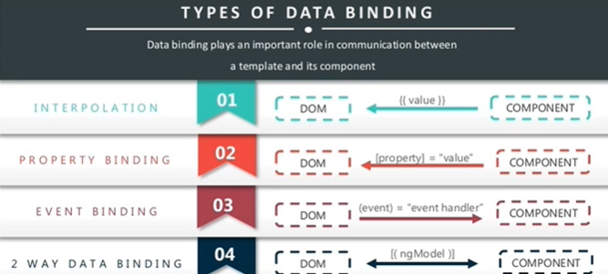

{{variableName}} is **string interpolation** markup.

{{methoName()}} **method interpolation.**

**Two Way Data Binding:** combo of property binding and event binding. (to make forms). ngModel directive is used to achieve 2 way data binding.

Interpolation code is written in html and defining variables/method will be done in ts files.

ts is business logic file.

**Router** is used to navigate from one component to another component. Routers are needed while navigating through a single page application. Without reloading the whole page we can navigate between components.

**Router-outlet** in Angular works as a placeholder which is used to load the different components dynamically based on the activated component.

From Angular8 onwards, we have Angular 8 **Reactive forms**(scalable,reusable). Angular forms are used to handle user input(to login/update/data-entry tasks).The 2 approaches to handle user input forms: Reactive forms, template-driven forms. **Template-driven** forms can be used if the application has a very basic form and logic.

Reactive Forms are created in component class(formControlName is used). Template-driven forms are created by directives (ngModel directive is used).

**FormControl** is used to track the value and validation status of an individual form control. **FormGroup** is used to track the same values and status for a collection of form controls. **FormArray** is used to track the same values and status for an array of form controls. **ControlValueAccessor** is used to create a bridge between Angular FormControl instances and native DOM elements.

**Directives** used to manipulate the DOM.

**Types of Angular Directives:**

1. components(Directives with a template),
2. Structural Directives(Adds & removes DOM elements to change DOM layout).

EX: ngFor - Repeater directive that iterates over collection of data,

NgIf - Adds or removes an elements from the DOM

NgSwitch - displays one element out of multiple elements based on a switch condition.

1. Attribute Directive (Changes the appearance or behaviour of an element).

Ex: NgStyle - sets inline styles dynamically based on the state of the component. NgClass - adds and removes CSS classes dynamically,

NgModel - displays a data property and updated as per the user interaction.

**Angular 8 Pipes:** Pipes(|) are used to Transform Data. we have uppercase pipe, lowercase pipe, date pipe, currency pipe, decimal pipe, percent pipe, json pipe, slice pipe etc.

**Angular Services:** <https://reqres.in/api/users> gives some json data. JSON/XML data(REST data) is used to transform data between 2 unknown applications .

**First Angular Project Creation after setup:**

d:\training\angular> *ng new my-dream-app* (to create new project)

Would u line to add Angular Routing : *NO*

Select *css* (by pressing enter)

*cd my-dream-app* (to go to our created folder)

*ng serve* (to start the server - to run any angular project u have to do this)(ctrl+C to stop server)

<http://localhost:4200/> (to see the default home page in browser)

Open VS code Editor, open folder and select the angular folder.

Open src/app/app.component.html/ Delete the content. Add ur own content.

Add content in src/app/app.component.css for styling.

The app.component.html content is injected to index.html using app-root, bcoz of selector app-root in app.component.ts.

Open index.html and change u want.

Create another component, in cmd prompt - *ng generate component hello*

write html, css file. Inject app-hello which is a selector in hello.component.ts in app.component.html.

In cmd prompt create another component - *ng generate component footer*

do same as for hello.

**Creating new Angular Project wipro-ltd**

Under Angular folder, open cmd prompt. *ng new wipro-ltd*

Enable routing : yes and select css.

*cd wipro-ltd*

*ng serve*

*ng generate component nav*

*ng g c about*

*ng g c contact*

*ng g c home*

*ng g c utility*

*ng g c employee*

*ng g c team*

*ng serve*

Open app-routing.module.ts to configure routing. Import components to configure navigation routing. Mention them in routes []. In app.component.html, inject router-outlet to make navigation works.

Open src/styles.css file, write code to make style to all components.

Create images folder under src/assets, and add images.

1. First work on nav component. write src/app/nav/nav.component.css. write ts and html files also. In app.component.html, inject nav component.
2. Next Work on utility component. Write css, ts and html. (utlity has calculator operation).
3. Next work on home component. Write css file and html file. No need of ts.

In the routing module.ts, for the home component, we didn’t mention any path there. So the home page will be displayed directly when open our application.

1. import FormsModule in app.module.ts to work with forms.
2. Now work on employee component, now we will do 2 way data binding.

*ng generate class employee* (do In cmdprompt: It will create only ts files)Write employee.ts file. Write ts, html and css.

1. import ReactiveFormsModule in app.module.ts to work with reactive forms.
2. Now work on contact component. import FormBuilder, FormGroup, Validators in contact.component.ts. Write ts, css, html.
3. in cmd prompt, create a new class, *ng generate class movie* as we are using this in about component. Declare variables in movie.ts file.
4. Open About component. import movie class in about.component.ts. Write ts, html, css files. Add bootstrap in index.html then we get borders for movies table.
5. Go to contact component again for pipes demo.
6. stop the server in cmd prompt. Create a angular service class. *ng generate service data.* or (ng g s data). and start the server. To use the service class, import HttpClientModule in app.module.ts.
7. Open data.service.ts. This file is used to interact with external data(Rest). for this, import HttpClient. Create an instance of http in constructor. Add few methods as well.
8. Now work on team component. Import DataService in team.component.ts and create instance of DataService in constructor. Write css, ts.

nav Component for Router Link

utility Component for making Calculator

employee Component for template-drive forms

contact Component for angular Reactive forms and demo of pipes

about Component for demo of Angular directives

team Component for Angular services.(using rest data in our application)